ANNUAL REPORT 2018

OHIO COMMUNITY THEATRE ASSOCIATION

The purpose of this statewide non-profit service organization is to promote excellence and creativity in live theatre by providing members educational opportunities for growth in artistic and technical aspects of theatre, and to promote community awareness, understanding and access to live theatre — alone or with other organizations.

Code of Regulations - Revised September 2012

 OCTA HISTORY

OCTA was formed in December 1953 with sixteen theatres and has provided support to community theatres through workshops, the annual regional OCTAfests - a showcase of community theatre productions, and through our three-day Annual Conference. Ongoing activities include a newsletter published 5 times a year, a Call to Conference once a year, membership directory, script lending library, monographs which update the OCTA information, and a resource directory used to locate props, costumes, equipment, etc. We do this with an all-volunteer Board and one part-time paid staff position.



The Ohio Community Theatre Association Board of Directors would like to express our thanks and appreciation to:

* All our patrons for their generous financial support - please continue to support the organization
* All the theatres that participated in the regional excerpt festivals
* Everyone who comes to our Annual Conference to see the excerpts, to learn new things about theatre by going to the workshops, to make new theatre friends, to share other theatre moments with old friends, to work on a committee to create good theatre, to be a part of the conference committee, to enjoy the late-night games and the sing-a-longs.
* Conference Co-Chairs John Falkenbach (W), Christi Thomas (W), Susan Barzda (SE) & Linda Smith (SE) their steering committee for planning and preparing everything for the conference
* To the Southeast and West Regions for co-hosting the conference
* The individuals who purchase our logo items
* The people who give us feedback with new ideas
* The people who help set up and tear down

**MANY THANKS TO ALL OF YOU!! WE APPRECIATE EVERYTHING THAT YOU DO FOR OCTA AND HOPE YOU WILL CONTINUE TO SUPPORT ALL OF OUR PROGRAMS.**

**MESSAGE FROM THE PRESIDENT**

A year of transition is how I would sum up the 2017-2018 year for OCTA. We have had many changes to the board many new faces and some old faces that have returned. We continue to struggle to get people to stay on the board or fill their role as a board member. We have a few mighty and dedicated people to this organization and they continue to fight on to ensure this organization will stay alive and well.

This year we had three goals set for OCTA. The first goal was Improving Communication at all levels within OCTA. I still feel like we are lacking in this area and have not done much to improve communication within the regions. The lack of regional reps being at the board meetings are affecting the ability to communicate needed messages to the delegates and member theaters.

The second goal was to define festival requirements by March board meeting. The board worked on taking a more responsible approach to the conference and will start to control more of what is done each year. As a board we want to make sure you have a similar experience and get some of the items you expect every year and not leave this up to the conference chair to decide. You will see many of the things you loved form the past brought back and some items that that board will now take on ownership for. As we move into 2019 we will be introducing a theater for the State conference and will have a hotel and theater experience. We are doing this to try to improve the experience of the OCTA conference experience and to try to drive attendance up and cost down.

The third goal is to improve the board and regional attendance to all board meetings. Northeast has not had a regional rep present at any meeting this year. Please encourage your regional reps to attend the board meetings if you are not hearing anything come to the next board meeting we need everyone's help! We will also be voting on an 8 region proposal this year to try to improve this issue. We feel if we sub-divide some of the regions we may be able to get more people active that may have not wanted to be active in the past due to how their regions were being run. This will also allow for better coverage of the regions as they will not be 100’s of miles between theaters.

We must focus on the future of OCTA and what it can become. We have many challenges still ahead, but I hope you all will continue to support this wonderful organization as we continue to strive forward and build a stronger community of thespians.

Let's continue to challenge ourselves to make this the best organization it can be!

Respectfully submitted,

Jesse Bernal

OCTA President 2017-2018

MC900015805[1]

**ADMINSTRATIVE DIVISION**

Dawna Kornick, Immediate Past President / Administrative Division Chair

Aara Wise, Administrative Assistant / Co-Historian

Susan Barzda, Secretary

Christi Thomas, Regional Rep Coordinator

Niccole Amersdorfer, Hall of Fame Chair

Amy Sullivan, Spirit of Community Theatre Chair

Mike Yonkura, Advocacy Chair / Co-Historian

Jason Neymeiyer, Delegate Coordinator

Sally Holmes, Sara Ledzianowski

And the members of the Executive Committee

As the Administrative Division we are responsible for the following:

* Nominations
* Policies/Job Descriptions
* Historian
* Advocacy
* Regional Rep Coordinator
* Delegate Coordinator
* Long Range Planning
* Hall of Fame
* Spirit of Community Theatre
* Conference Site Selection

The Administrative Division started the year reviewing time-lines and setting standard dates for accomplishments. Members reviewed timelines and job descriptions and job assignments were made. A discussion was held regarding plans to celebrate June as Ohio Community Theatre Month. A review of the budget was done; no additions or changes were suggested.

Christi Thomas, Regional Rep Coordinator, chaired the Regional Rep meetings during the year. Aara Wise, Historian, continued to record the events and programs of OCTA in photos and other documentation.

Coordination of State Conference Chair & Conference Site Selection was done by the Admin Division this year. We have appointed Co-chairs for the upcoming conference in the Northwest Region and the 2020 Chair in Southwest Region. We are currently investigating sites and chairs for 2021 in the Northeast Region.

Mike Yonkura was selected to fill the Advocacy Chair Position; he attended the Arts Day and Governor’s Award for the Arts Luncheon on May 16, 2018. Richard Cordray, Democrat Candidate for Governor was present; however, few Legislators were in attendance. The current First Lady of Ohio is a huge supporter of the Arts. There are state funds available to theatres so those who seek funding should contact their State Representatives to see what is available in their area.

Huge congratulations to Fred Wise, late OCTA Historian, on receiving the AACT Special Recognition Award presented to individuals and organizations whose contributions to community theatre are far reaching and of a special nature. Aara Wise, Kate Charlesworth-Miller, and Dawna Kornick attended the AACT WorldFest June 2018 in Venice, Florida to accept the award on Fred’s behalf.

We secured a booth to promote and celebrate OCTA and Community Theatre Month at the Summit StageFest on Saturday June 2, 2018 – “All the Square’s A Stage”. Summit StageFest brings together theater groups from all over Northeast Ohio for a free celebration of live performance, art, and food in the heart of Akron’s eclectic Highland Square neighborhood. For more information or details please visit their website at <https://stagefest.org/>.

Mike Yonkura developed a list of Newspapers, Radio, and Television stations so that he can send them press releases. Please check the list and add contact info for news organizations in your locale that aren’t already on the list. Mike provided a press release for Community Theatre Month in June.

Amy Sullivan, Spirit of Community Theatre Chair, presented the nominations for the Spirit of Community Theatre Award. The Administrative Division reviewed nominees and made their selections. Amy Sullivan or an Admin member attended the Regional festivals to present the awards. Congratulations to the 2018 Spirit of Community Theatre Award winners!

Niccole Amersdorfer, Hall of Fame Chair, presented the nominations for The Hall of Fame Award. The division reviewed candidates and selected three individuals to induct into OCTA’s Hall of Fame.  The winners will be announced and honored at the Sunday Night Banquet at State Conference at the Crowne Plaza.

The Administrative Division passed out copies of the proposed amendment to the Code of Regulations; to be voted on at the Delegates meeting at Conference if there is a change in number of regions.

The division reviewed the OCTA Board positions that need to be filled - there are six (6) 3-year terms, one (1) 2-year term, and two (2) 1-year terms to fill at the present time.  The Delegates Annual Meeting will be held at 5:00 p.m. in the Buckeye Room at the Crowne Plaza.   The Delegates will be sent information on issues to be presented for a vote prior to the meeting. Division members who are not running as a candidate will be assisting at the sign-in table prior to the meeting and in counting the ballots.  Susan will type up the ballots for the board elections prior to the meeting.  Mike passed out a draft of a press release for the State Conference which will be sent out to news services in the areas serving the theatres which are excerpting.  Next year the division will focus on development of a 5-year plan for divisions.

Respectfully submitted,

Dawna Kornick, Immediate Past President/Administrative Division Chair

**REGIONAL REP COORDINATOR REPORT**

The regional reps tried to focus on communication this year, trying to have better communication with all the theatres in their region.  Most of the goals set by the reps at the beginning of the year were meet. However, we were all disappointed that the number of excerpts in most regions was down this year.

Respectfully submitted,

Christi Thomas, Regional Rep Coordinator

**OCTA HISTORY**

In conjunction with MM/PR, Mendell Hibbard has worked very hard this year to find original start dates for member theaters so that OCTA has a correct catalog of anniversaries.

Mike Yonkura has been working on advocacy on behalf of OCTA this year.

Aara Wise took pictures at all the regionals this year. She also traveled to Venice Florida to attend the AACT International Festival to accept the Special Recognition Award on behalf of our Historian-Fred Wise. She was accompanied by Past President Dawna Kornick and 3rd Vice President Kate Charlesworth-Miller and Kate’s daughter, Nancy.

Respectfully submitted,

Mike Yonkura & Aara Wise, Co-Historians

**MM/PR (Marketing Membership / Public Relations) Division Report**

Division Members/Responsibilities:

Susan Metz Guthrie (SW) 2nd VP, MM/PR

Mendell Hibbard (C): Theatre Anniversary Database Update

Tahrea Maynard (C): Social Media John Grote (C): Cuelines (resigned)

Jai Furlong-Pierce (C): Publicity, Advertising & Promotions Harley Antesky (NW): Website

Peggy Kenney (SW): OCTA Gems Cindy Emmer (SW): OCTA Gems

Although the MM/PR Division was originally comprised of at least eight members, the usual gathering at our scheduled meetings consisted of 3-5 members. We still managed to accomplish some of our goals for the year, which are outlined below.

Our division had many (and some quite spirited) conversations regarding the issue of the wording of Section B, Article VII, Section 1(b) of OCTA’s Code of Regulations. Members of the division ultimately tabled further discussion of this issue in anticipation of a complete review and possible modification of the Code of Regulations in the near future.

The Board approved the following theatres for membership in OCTA:  
  
*Bellevue Society for the Arts (NW) *Ohio Valley Summer Theatre (SE)

*Striplight Community Theatre, Inc. (SE) *Nova Theatre

*Sunset Players (SW) *Twin Mask Performing Arts Center (NE)

*Dover Playhouse (NE) *Coach House Theatre (NE)

Peggy Kenney, Cindy Emmer, and John Grote worked on formulating a new program for our younger attendees at State Conference called “OCTA Gems”. The program would focus on providing entertainment, information, and other benefits to make State Conference more appealing and relevant to a younger participant. Peggy and Cindy also worked on a mentoring program (“Ambassadors”) for new OCTA member theatres.

Jai Furlong-Pierce worked on a new OCTA brochure to include, among other things, information, photos, and links to member theatres.

Upon John Grote’s resignation as editor of “Cuelines”, Aara Wise assumed the position of “Cuelines” editor, with the help of Christi Thomas, Jesse Bernal, Peggy Kenney and others.

Mendell Hibbard did extensive work on the member theatre anniversary database update and has given his results to Aara Wise for future reference, possibly for inclusion in “Cuelines” and for recognition at State Conference.

The Division recognized the need to update the resources manual and is in the process of looking at ways to collect the most up-to-date information. Mendell Hibbard will create a list of shows that have been done by member theatres in the past three years ago for potential use as a resource for costumes, set pieces, props, etc.

The Division instituted plans for a survey for the Tech Awards and will forward the results to the Programming Division upon completion. Jesse Bernal is heading-up this survey.

A special thanks to Jesse Bernal for taking part in many of the Division meetings and offering his invaluable knowledge and assistance.

Respectfully submitted,

Susan Metz Guthrie, 2nd Vice-President/MMPR Division Chair

**FUNDRAISING DIVISION**

The Fundraising Division met at each Board meeting this year to work on ways to raise funds for OCTA, to bring value to the Patron Program, to acquire quality items for the Silent Auction at State Conference, to brainstorm ideas for new logo items, and to increase participation in fundraising activities.

**OCTA Scholarship Program**

17 applications were received this year. After much discussion, the committee identified the students who will receive one of several $500 scholarships which are available this year, including the OCTA Patron, Fred Wise and Larry Weber Scholarships. Many thanks to the Fundraising Committee for their commitment to this important job, and kudos to all the applicants for their dedication to their art!

**Silent Auction**

A one-page handout was created outlining Silent Auction ideas and themes to encourage regionals, theatres and individuals to participate. The handout offered suggestions of what to donate, and also what not to donate, as this had become an issue in the past. This handout was distributed to regional reps to send to their theatres, as well as being made available to the board members. Silent Auction at State Conference is an important fundraiser for OCTA, and funds raised go to help with many OCTA programs, including the OCTA scholarships.

**Patron Program**

We sent out the annual Patron solicitation letter in May. We very much appreciate all Patron donations, which allow OCTA to continue providing the important programs and scholarships it does.

Patron Benefits:

All persons who donate in any amount to the general fund for OCTA, or to the OCTA Scholarship fund, receive a yearly emailed subscription to 'Cuelines' and a listing on the Patron page of the newsletter and in our Annual Report. Donations are tax deductible to the extent allowed by law. For tax purposes, patron payments are recorded on the calendar year, January 1 to December 31st. For Patron Benefit purposes, the payments are counted from the day after State Conference to the following year's State Conference (so donations in December of one year will count towards Patron Benefits at the following years Labor Day weekend conference).

Patron Levels:

Applause donations up to $24

Curtain Raiser $25+ donation (includes one reserved seat for the excerpts.)

Bravo! $100+ donation (includes one reserved seat for the excerpts.)

Standing Ovation $250+ donation (includes two reserved seats for the excerpts, and one reserved 8

top banquet table at the Sunday banquet.)

**Logo Sales**

This regional season, we focused on clearing out old inventory at the regional OCTAFests and were very successful at this. New items have been purchased for sale at the State Conference, and we are always seeking input on what items our patrons and OCTA attendees would like to purchase.

Below are the individual regional total sales for 2018:

Central $234.00

Northwest $78.00

Northeast $20.00

Southwest $165.00

West $45.00

Southeast $27.00

Totaling - $569.00

Respectfully submitted,

Kate Charlesworth-Miller, 3rd Vice President, Fundraising Division

**PROGRAMMING DIVISION REPORT**

The members of the Programming Division have worked diligently on their assigned tasks, bringing the varied programs to fruition throughout the state. They have all done well in their duties.

The Guide/Respondent program continues to offer “another set of eyes” to theatres for their productions and/or excerpts. Members may use this service twice in a year, at no cost to the theatre.

The statewide technical competitions are designed to help recognize the “unsung heroes” of our local productions – those behind-the-scenes designers and technicians who help make our shows stand out and sparkle. It includes such areas as set design, costumes, makeup, newsletters, brochures, and website design. Our thanks go to those volunteers who offered their time and talents to judge this year’s entries.

The OCTA Lending Library is always available to serve our members. If a theatre needs to read a script to determine is viability for its season, they can check with the library to see about obtaining a copy of the show. If the library does not have a title you are interested in, please submit that show to the library and we’ll make an effort to obtain it.

The OCTA Fest regionals ran well in all 6 regions, as well as OCTA, Jr. and the State Conference. The division took comments and suggestions offered from last year to improve conditions and procedures for this year. We are continuing to pursue ways to make these festivals even more inclusive, instructive, and fun-packed for all.

With this being an AACTFest year, additional efforts were made to hold this adjudication and selection of Ohio’s representatives to the Region 3 AACTFest, to be held in Kokomo, IN, in April, 2019.

Plans are already progressing for the 2019 State Conference in the NW Region. For the first time in years, the State excerpt festival will be held in a working theatre. We look forward to a great Conference – and lots of fun.

This division consisted of 12 members (for all or part of the year): Mitch Antesky, Joe Barton, John Falkenbach, Billie Harmon, Michelle Johnson, Wayne Kirsch, Dan Maloney, Kevin Noll, Grant Perry, Linda Smith, Christi Thomas, and Aara Wise. Each of these spent a lot of time and effort to assure the programs of OCTA continued to be available to the membership and that they run as efficiently as possible. I commend all of them for their work this year. Thank you all.

Respectfully submitted,

Wayne Kirsch, 1st Vice President / Programming Division Chair

**SECRETARY’S REPORT**

At the September 2, 2017 Annual Meeting of Theatre Delegates at the Crowne Plaza Columbus North the following individuals were elected to serve on the OCTA Board of Directors:

Susan Barzda 3-year term Susan Metz Guthrie 3-year term Jesse Bernal 3-year term Wayne Kirsch 3-year term John Grote 3-year term Mary Maynard 3-year term Dan Maloney 2-year term Jai Furlong Pierce 1-year term Grant Perry 1-year term

On Monday September 4, 2017 the new and returning board members along with the regional representatives met to elect the following members to the Executive Committee:

Jesse Bernal President Wayne Kirsch 1st Vice President Susan Metz Guthrie 2nd Vice President Kate Charlesworth-Miller 3rd Vice President Susan Barzda Secretary

They will serve on the Executive Committee along with Dawna Kornick, Immediate Past President.

On September 23, 2017 the Executive Committee met in Columbus to make divisional committee assignments and to plan and to set goals for the coming year. The full board met in retreat on October 21, 2017 in Dublin, Ohio to review the assignments and to review goals and expectations for the 2017-2018 year. Regional OCTAfests were held in June and July 2018 in all six regions. Full board meetings were held on September 4, October 21, and December 4 in 2017 and on March 17, May 19 and July 21 in 2018. Individual attendance at the board meetings for the year are reported below.

**Executive Committee** **Present Missed % attendance** President Jesse Bernal 6 0 100% 1st Vice President Wayne Kirsch 6 0 100% 2nd Vice President Susan Guthrie 5 1 83% 3rd Vice President Kate Charlesworth-Miller 6 0 100% Secretary Susan Barzda 6 0 100% Immediate Past President Dawna Kornick 4 2 67%

**Board Members-at-Large**  **Present Missed % attendance** Joe Barton 5 1 83% John Falkenbach 6 0 100% Jai Furlong Pierce 6 0 100% John Grote 4 2 66% Mendell Hibbard 5 1 83% Michelle Johnson 6 0 100% Peggy Kenney 4 2 67 % Mary Maynard 2 3 40% (Resigned 7/21/18) Dan Maloney 5 1 83%

Grant Perry 3 3 50% Leigh Sandmann 3 3 50% (Resigned 3/17/18) Kathy Sturm 1 2 33% (Resigned 12/1/18) Mike Yonkura 3 0 100% (appointed 3/17/18) Mark Miller 0 0 NA (appointed 7/21/18)

**Regional Representatives** Representative attendance is counted by region and reported individually.

**Present Missed % attendance**

**Central Region** Tahrea Maynard 2 3 40% (Resigned 7/21/18) Tim Pierce 6 0 100%

**Northeast Region**  Tammy Carder 1 5 17% Benjamin Gavitt 0 6 0% Autumn Ridler 0 6 0%

**Northwest Region** Harley Antesky 0 6 0% Mitch Antesky 1 5 17% Millie Butts 6 0 100% Sara Ledzianowski 2 4 33% Jason Nyemeiyer 2 4 33%

**Southeast Region** Billie Harmon 1 5 17% Sally Holmes 1 5 17% Jane Mancini 6 0 100% Linda Smith 5 1 83%

**Southwest Region** Cindy Emmer 4 0 100% ( started 12/17) Ray Lebowski 6 0 100% John Masterson 4 2 67% Kevin Noll 4 2 67%

**West Region** Niccole Amersdorfer 6 0 100% Christi Thomas 6 0 100%

**Others**  Aara Wise (Administrative Asst. /Historian) 6 0 100%

Mike Yonkura (Historian) 6 0 100%

On **September 4, 2017**, in addition to electing members to the Executive Committee, the board also voted:

1. To approve the remaining proposed changes, updates, and affirmations of the OCTA Board Policies and Procedures.
2. To approve Actors Collaboration of Toledo in the Northwest Region as a new member theatre.

On **OCTOBER 17, 2017** the board voted:

1. To approve Michael Schacherbauer as an Honorary Lifetime Member, retroactive to September 3, 2017.
2. To approve the Bellevue Society for the Arts as a new member theatre. They are very active in the Northwest Region, delegates are Bradley Rowe and John Minor, and they have paid their dues after a lapse of membership for 2 years.

On **December 2, 2017** the board voted:

1. To approve the proposed 2018 Budget.
2. To approve the appointment of Jesse Bernal as Chair of the 2019 State Conference, with Michelle Johnson as the Co-Chair.
3. To approve the selection of the Holiday Inn French Quarter in Perrysburg as the site of the 2019 State Conference. It will be used as the hotel and the banquet location, with Owens Community College Center serving as the venue for excerpts, workshops, and other activities.

On **March 17, 2018** the board voted:

1. To approve Mike Yonkura’s appointment to the OCTA board to fill a vacancy.
2. To approve sending Mike Yonkura, as Advocacy Chair, to attend the May 16, 2018 Arts Day and Governor’s Awards for the Arts Luncheon, sponsored by the Ohio Arts Council and Ohio Citizen’s for the Arts, and for OCTA to pay for his ticket for $50.00. It will be at the Columbus Athenaeum.
3. To table the vote to approve the Actors Theatre of Fairborn as a new member theatre of OCTA until West Regional Reps could check with the theatre and determine if they continued to desire to pursue membership, as well as check the status of the theatre.
4. To approve the Ohio Valley Summer Theatre, of Athens, as a new member theatre of OCTA. They are from the Southeast Region, were previously members of OCTA, and have paid the dues.
5. To approve the Striplight Community Theatre, from Weirton, West Virginia in the Southeast Region as a new member theatre of OCTA. They had previously had a trial membership in OCTA and would like to join. They have paid the dues.

On **May 19, 2018** the board voted:

1. To approve the proposed amendment to the Code of Regulations, which will be presented to the Delegates at the Annual Delegates meeting for a vote, in the event that Reorganization Plan D is elected by the Delegates at the meeting. The current language reads:

“Article XI- Organizational Structure - The Board of Directors shall divide the state into six (6) regions: Central, Northeast, Northwest, Southeast, Southwest, and West. “

The Proposed Language (if reorganization Plan D is elected):

“Article XI – Organizational Structure -**Effective as of September 3, 2019**, the Board of Directors shall divide the state into **eight (8)** regions: Central, **East, North**, Northeast, Northwest, Southeast, Southeast, and West.

1. To approve the Actors Theatre of Fairborn Ohio in the West Region as a new member theatre of OCTA.
2. To approve the appointment of Dan Maloney as Conference Chair for the 2020 State Conference.
3. To approve INNOVA Theatre from Fairfield Ohio in the Southwest Region as a new member theatre of OCTA. They are taking a trial membership where the dues have been waived for the first year.
4. To not approve the Sunset Players Inc. from Cincinnati in the Southwest Region as a new member.
5. To approve the waiver of the late fees for Sunset Players Inc., and to accept the payment of their dues to bring their membership back into compliance as a member.
6. To approve the Twin Masks Performing Arts Centre in Twinsburg in the Northeast Region as a new member theatre of OCTA.
7. To approve the Dover Players (also known as Dover Playhouse) in North Olmstead in the Northeast Region as a new member theatre of OCTA.
8. To approve the Coach House Theatre in Akron Ohio in the Northeast Region as a new trial member theatre of OCTA. Fees have been waived for the first year.
9. To approve giving $10.00 off for any Ambassador Theatre’s annual membership fee after they have been an ambassador theatre for one year; and for this action to be only for a 2-year trial. Amendment was made, and a vote was taken.
10. To approve the transfer of 10% of the Patron fund to the Scholarship fund, in the amount of $723.07.
11. To approve the transfer of an additional $223.07 from the Patron fund to a 4th Scholarship.

It was noted at this meeting that the Striplight Community Theatre’s check came back from a closed account. Their membership is now void for this year.

On **July 21, 2018** the board voted:

1. To approve the appointment of Mark Miller to the board for the remainder of the 2017-2018 year to fill a vacancy.
2. To approve Act 2 Productions as a new trial member theater of OCTA in the Northwest Region.
3. To approve Merit Theatre Company of Kentucky as a new member theater of OCTA in the Southwest Region.
4. To approve the Brookville Community Theatre as a new trial member theatre in the West Region.

Respectfully submitted,

Susan Barzda, Secretary

**OCTAFEST JR. 2018**

The 13th Annual OCTAFest Jr. was held on Saturday, August 4th at Owens Community College in Rossford, Ohio. We had 5 theatres from all over Ohio sharing the talent of their theatre’s youth ranging from ages 6 – 18 years old. Theaters received individual awards. Due to changes and scheduling conflicts instead of sending 2 theaters to the Friday State Festival, Best of Show plaques were awarded to 2 theaters and up to 2 actors were chosen from each cast as an All-Star Cast.

Theatres participating this year were 3B PRODUCTIONS~*Hairspray;* TOLEDO REPERTOIRE THEATRE~Heathers, The Musical HS Ed.*;* HORIZON YOUTH THEATRE~*All I Needed To Know I Learned In Kindergarten;* LITTLE THEATRE OF TUSCARAWAS CO~*15 Reason Not To Be In A Play;* WATERVILLE PLAYSHOP*~Alice In Wonderland Jr. .*

There were over 200 cast, crew and volunteers! As we opened the registration table, we had approximately 95 guests show up that day to support the youth!

Thank you to our OCTA volunteers that said “yes” to helping in the key positions: Grant Perry & Erika Bihn – Stage Managers, Lights & Sound – Rick Clever & Geoffery Mintz, Michelle Johnson – Timekeeper and Announcements, our three fantastic responders: Theresa Benyo-Marzullo, Kathy Hyland, and Susan Metz-Guthrie.

At the end of the day Wayne Kirsch, who graciously stepped in as OCTAFest Chair, announced the over 43 awards deliberated on by three FANTASTIC responders, Theresa Benyo-Marzullo, Kathy Hyland and Susan Metz Guthrie.

The Best in Show plaques were awarded to 2 theaters that represented the best of the best. This year’s winners were: 3B Productions with *Hairspray* and Horizon Youth Theatre with *All I Needed to Know I Learned in Kindergarten*. A new award that began last year as the “Gypsy Award” has been renamed to the “Ensemblist Award. There was a tie with Emma Parrish and Tyler Cowdery receiving awards. An All Star Cast was chosen with 2 cast members from each show receiving medals. Thank you to all the directors and their cast for a wonderful day of theatre!



Respectfully Submitted,

Michelle Johnson & Dan Maloney, 2018 OCTAFest Jr. Co-Chairs

**OCTA JR. AWARDS 2018**

***ALL I REALLY NEEDED TO KNOW I LEARNED IN KINDERGARTEN***

Thomas Long – Merit in Acting

Annie Valantine – Merit in Acting

Daniel Cagle – Excellence in Acting

John Colvin – Excellence in Acting

Isaac Douglas – Excellence in Acting

The Cast – Excellence in Ensemble

Cassie Greenlee – Excellence in Directing

***HAIRSPRAY***

Dylan Coale, Cayla Kale & Kala Navarro – Merit in Wig Design

Joe Barton/3B Costumes – Excellence in Costumes

Bob Marzola – Merit in Choreography

Joe Barton – Outstanding in Directing

Nick Adams – Excellence in Duet Performance as Edna Turnblad

Adam Lenhart – Excellence in Duet Performance as Wilbur Turnblad

Chloe Smallwood – Outstanding in Musical Theatre Performance and Maybelle

Jesse Bernal – Excellence in Set Design

Tyler Cowdrey – Merit in Musical Theatre Performance as Link Larkin

Emma Parrish Excellence in Musical Theatre Performance as Prison Matron

Sarah Kinney – Merit in Acting as Prudy Pingleton

Aly Rollins – Merit in Acting as Penny Pingleton

The Cast – Excellence in Ensemble

Joelle Stiles – Merit in Acting as Velma Von Tussle

Claudia Cromly – Merit in Acting as Amber Von Tussle

Tyler Strayer – Excellence in Musical Direction

***HEATHERS, THE MUSICAL - HIGH School edition***

Grace Mauk – Merit in Musical Direction

Domonique Glover – Excellence in Choreography

Vicki Monhollen – Merit in Directing

Hannah Buck – Merit in Acting as Veronica

Tristan Daniels – Merit in Acting as Jason Dean (J.D.)

Paige Titsworth – Merit in Vocal Performance as Heather McNamara

Savannah Nine – Excellence in Musical Theatre Performance as Martha

Alex Evans – Excellence in Vocal Performance as Ram’s Dad

***ALICE IN WONDERLAND JR.***

Joe Barton/3B Productions – Merit in Costumes

Rachel Wozniak – Merit in Acting Duo as Tweedle Dee & Tweedle Dum

Mackenzie Slagle – Merit in Acting Duo as Tweedle Dee & Tweedle Dum

Ben Bascuk – Excellence in Acting as White Rabbit

Tyler Cowdrey – Excellence in Acting as Mad Hatter

Brooke Dove – Excellence in Musical Theatre Performance as Caterpillar

Mia Pyle – Merit in Acting as Cheshire Cat #2

***15 REASONS NOT TO BE IN A PLAY***

Grace Williams – Excellence in Acting

Will Hammerstrom – Merit in Acting

The Cast – Merit in Ensemble

**BEST OF SHOW**

HAIRSPRAY

ALL I NEEDED TO KNOW I LEARNED IN KINDERGARTEN

**ENSEMBLIST AWARD**

Tyler Cowdrey

Emma Parrish

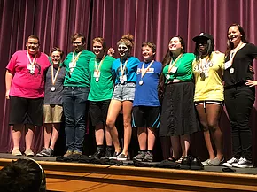

**OCTA ALL STAR CAST**

John Colvin

Daniel Cagle

Chloe Smallwood

Nick Adams

Savannah Nine

Tristian Daniels

Ben Bascuk

Brooke Dove

Grace Williams

Will Hammerstrom

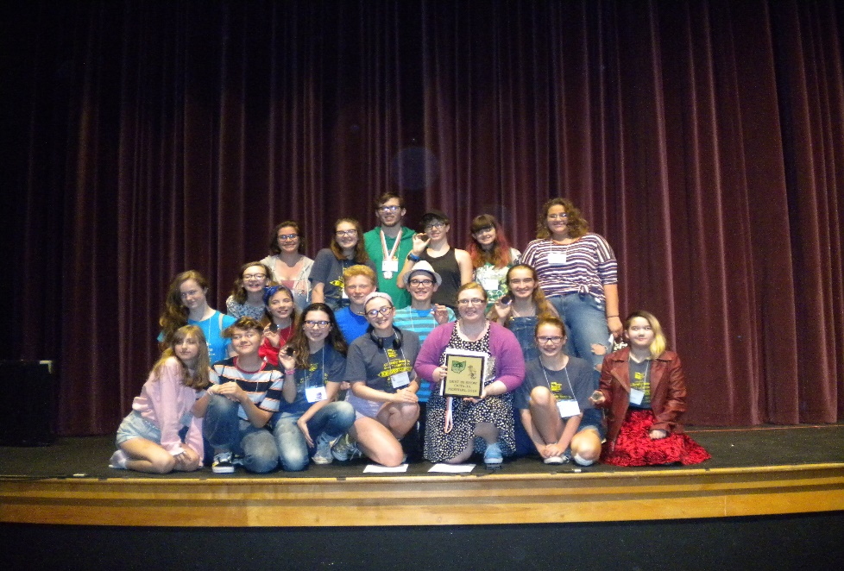

**ALL I NEEDED TO KNOW I LEARNED IN KINDERGARTEN**

**HORIZON YOUTH THEATRE**

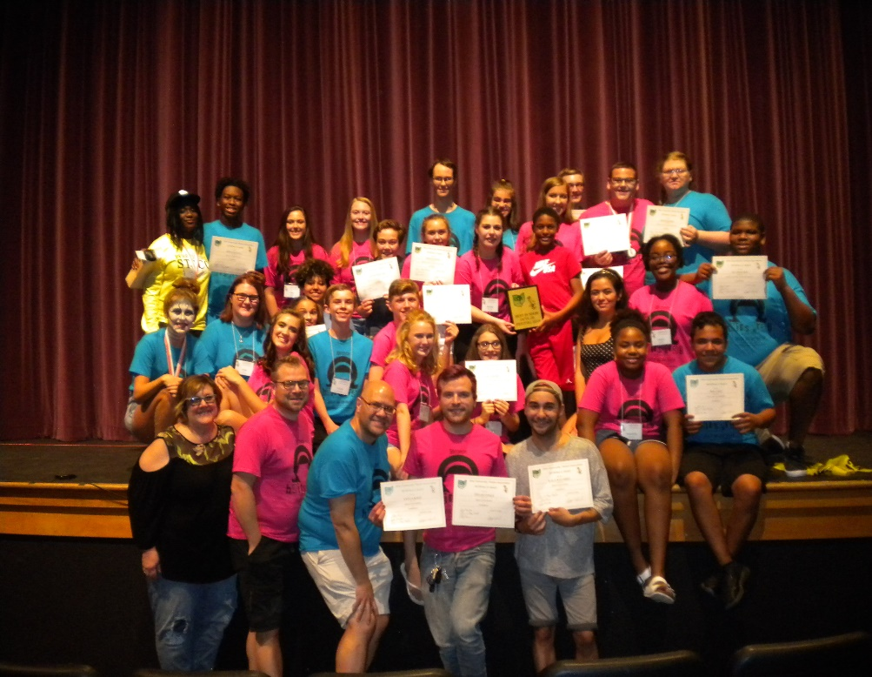

**HAIRSPRAY**

**3B Productions**

**ADMINISTRATIVE ASSISTANT REPORT**

“Believe” was the theme for the year. Many new items were introduced by Conference Co-chairs Kathy & Geri. Some items worked, while others didn’t work so well. We took the conference evaluations and began planning for 2018. I was asked to be at Central, Northeast and Southeast regions as Administrative Assistant as well as OCTA Jr.

Total Number Registered 2017 Conference 376

Pre-Registered

Full package Participants 208

Saturday One Day Participants 78

Sunday One Day Participants 66

Musicians 9

Walk-in registrations

Full Package 3

Saturday Only 5

Sunday Only 3

Session Bracelets ?

First Time Attendees 130

MC900355865[1]

**2017 Financial Report**

Jan 1, 2017 Account Balance $14,966.66

Dec 31, 2017 Account Balance $15,677.32

Central Region Balance - Dec 2017 $1,587.35

Southeast Region Balance - Dec 2017 $2,128.64

2017 Total Income $57,876.33

2017 Total Expenses $60,237.33

Profit/**Loss** ($2,361.00)

Total Account Balance - Jan 2018 $15,677.32

Checking Account Balance 7/31/18 $7,587.04

Credit Card Account Balance 7/31/18 $1,000.00

Allied Bernstein Account as of 6/30/18 $3,543.67

CD Amounts as of 7/31/18

$1,002.50

$2,058.67

$2,133.82

Total $5,194.99 Gain of $5.34

For the 2018 festival year, it was decided by the Executive Board to begin sending the Administrative Assistant back to the regional festivals. She attended all except Southwest due to being at AACTfest. Regions were responsible for lunch while working, but OCTA took back the expense of hotel and mileage.

Respectfully submitted,

Aara Wise,Administrative Assistant

**PATRONS - JAN 1, 2017 – AUG 22, 2017**

**STANDING OVATION ($250. – UP)**

Anonymous Jesse Bernal

Kate Charlesworth-Miller Mendell Hibbard

Ed & Sylvia Meade-*In Memory of René Saxton & Dan Reich*

Larry Weber-*In Memory of Fred Wise*

**BRAVO! BRAVO! ($100-$249)**

3B Productions Northeast Region-*In Memory of Fred Wise*

John Aiello Susan Barzda

Dawna Kornick-*In Memory of Fred Wise* Lou Ann & Tony Giedlinski

Dr. Gary Gillen

Michael Schacherbauer & Don Savolainen-*In Memory of Fred Wise*

Bonnie Segaard Jim & Linda Toth

Marilyn Stocker-*In Memory of Fred Wise* Sheryl Wise-*In Memory of Uncle Fred Wise*

**CURTAIN RAISER ($50-$99)**

Mitch & Scott Antesky Doug Browell Rich & Amanda Coburn

Karen Finn Glen & Lisa Napier Garcia Rex Huffman

Michelle Johnson Allen Kasack Perry & Susan Jones-*In Memory of Fred Wise*

Julie Lane Ray Lebowski Sara Ledzianowski

John Marwede Kara & Bob Mettile-*In Memory of Fred Wise*

Bob & Cynthia Mottel Shirley Nebergall Ray & Deb Nuhfer

Pat Potter Mitch Rutledge Sue Snyder

Patti Vincent-*In Memory of Fred Wise* Nancy Wolf Jerry Zimmerman

**APPLAUSE PATRONS ($25-$49)**

Tom Albury Michael Blake~*In Memory of Wayne Livingston* Michelle Burdett

Millie Butts Joan Conlon Debi Devore Chris Dick

Jim Gremba Sally Holmes Kathy Hyland C.J. Jamison

Peggy Kenney Norma Krueger-*In Memory of Fred Wise* Vashti Larsen Jim Lockwood Eric & Doris Lowney-*In Memory of Fred Wise* Geri Martin Jane McBride Susan Meade Melissa Metz Mark Miller Susan Moreland Mary Morse Connie Murphy Stayce Nabors

Jason Neymeiyer Alex Nine Sue Rapier Linda Rich

Linda Roll Donna Stasel-*In Memory of Fred Wise* Tim Steiner Nancy Steyer Kathy Taylor Debbie & Bill Whipkey-*In Memory of Fred Wise* Aeryn Williams

**OPENING KNIGHTS ($10-$24)**

Niccole Amersdorfer Jennifer Kaufman Rick & Kristin Lee

Judy Manley Teresa Myers



**PATRONS - JAN 1, 2018 – AUG 17, 2018**

All donation made after 8/17/18 will be published in the January 2019 newsletter

**STANDING OVATION ($250. – UP)**

Anonymous Jesse Bernal Kate Charlesworth-Miller/Mark Miller *(In Memory of Fred Wise)*

Geri Martin Richard & Susan Metz Guthrie Larry Weber Donna Wollenslegel

**BRAVO! BRAVO! ($100-$249)**

3B Productions Niccole Amersdorfer Joe Barton Susan Barzda

Donia & Britton Collier David & Sheralyn Erickson *(In Memory of Michael Schacherbauer)*

Michelle Johnson Jennifer Kaufman Dawna Kornick *(In Memory of Michael Schacherbauer)*

Ray Lebowski Little Theater Off Broadway *(In Memory of Michael Schacherbauer)*

Bonnie Segaard Julie Shuran *(In Memory of Michael Schacherbauer)*

**CURTAIN RAISER ($50-$99)**

Nancy Abramson *(In Memory of Michael Schacherbauer)* Michael Blake Tim & Cheryl Bolton

Rich & Amanda Coburn Judi & Larry Cox *(In Memory of Michael Schacherbauer)*

Rick & LuAn Cunningham *(In Memory of Michael Schacherbauer)* Trish Davis

Glen Garcia & Lisa Napier Garcia Rex Huffman Allen Kasack

Michelle Johnson *(In Memory of Michael Schacherbauer)* Julie Lane Alex Nine

Sara Ledzianowski Rick & Kristin Lee Ray & Deb Nuhfer Pat Potter

Connie Parrott *(In Memory of Michael Schacherbauer)* Mitch Rutledge

Sheila Rosen *(In Memory of Michael Schacherbauer)* Arny & Stephanie Stoller

Mary Shankland *(In Memory of Michael Schacherbauer)* Mike Yonkura

Tim & Della Shier *(In Memory of Michael Schacherbauer)* Stephen & Teresa Van Sickle

**APPLAUSE PATRONS ($25-$49)**

Betty Billingsley (*In Memory of Michael Schacherbauer)* Michelle Burdett Millie Butts

Joan Conlon Chris Dick Frances Gibser Susan Gordon John Grote

Mendell Hibbard Kathy Hyland C.J. Jamison Peggy Kenney Judy Manley

Pam & Donald McDowell Susan Moreland Mary Morse Connie Murphy

Bonnie Rake Sue Rapier Linda Roll Sharon Shelton Wes Taylor

Aeryn Williams

**OPENING KNIGHTS ($10-$24)**

Pam Rumer Christina Siciliano Hans B. Unser

Patrons can be identified at conference with purple ribbons attached to their name badges. Patrons contributing $25.00 or more receive preferred seating during the conference excerpts. Patrons contributing $250.00 or more receive preferred seating during the Sunday Banquet.

Through the generosity of our Patrons we able to provide services, scholarships, programs and events. We thank you for your continued support of OCTA!

**2017 ANNUAL CONFERENCE WRAP-UP**

The 2017 OCTA State Conference took place at the Crowne Plaza North, Worthington, September 1 through September 4. The theme, The Magic Show, was showcased throughout the weekend with the magic created on the stage by 14 excellent excerpts, as well as numerous workshops including making props from everyday items, puppetry, ballroom dance, and improv. The Sunday night banquet was a plated dinner, culminating with a full stage show by magician, Drew Murray.  Late night entertainment included a new game SINGO, which packed the room with players filling out bingo-like cards, while singing along to music ranging from oldies to contemporary pop. Food trucks were on site to help slake the late-night munchies, and MTI once again provided its late-night sing-along. All in all, it was a weekend of magic making new friends and reconnecting with old acquaintances, and recognizing that our theatre community, and all of the people who are a part of it, make magic every day.

Respectfully submitted,

Kathy Sturm & Geri Martin Co-Chairs

2017 Conference Chair

**2017 CONFERENCE EXCERPT AWARDS**

VANYA AND SASHA AND MASHA AND SPIKE – Beavercreek Community Theatre

Merit is Acting as Vanya – Chuck Larkowski

THE LAST LIFEBOAT – Dayton Theatre Guild

Merit is Costumes – Carol Finley

Merit in Directing – Jeff Sams

Merit in Acting as J. Bruce Ismay – Matt Lindsay

Merit in Acting as Thomas Ismay/Others – J. Gary Thompson

Excellence in Ensemble – The Cast of The Last Lifeboat

Excellence in Acting as William Randolph Hurst – Mike Beerbower

Outstanding in Sound Design – K.L. Storer

Outstanding in Set Design – Jeff Sams

LOVE/SICK – Village Players

Excellence in Acting as Louise – Patricia Mullins

Excellence in Acting as Bill – Michael Ireland

Excellence in Acting as Mark – Scott Unes

WORDS, WORDS, WORDS – Aurora Community Theatre

Merit in Acting as Swift – Travis Reilly

Merit in Acting as Milton – Rob Walter

Merit in Acting as Kafka – Macey Staninger

ALWAYS…PATSY CLINE – The Drama Workshop

Outstanding in Costumes – Dennis Murphy

Outstanding in Wig Design – Jim Percival

Outstanding in Sound Design – Jason Cox

Outstanding in Set Design – Ray Persing

Outstanding in Directing – Robert Weidle

Outstanding in Musical & Vocal Directing – Linda Abbott

Outstanding in Musical Accompaniment – The Bodacious Bobcats Band

Outstanding in Ensemble – The Cast of Always…Patsy Cline

Outstanding in Musical Theatre Performance as Patsy Cline – Cynthia Mottel

Outstanding in Musical Theatre Performance as Louise Seger – Jennifer Keith

FOREVER PLAID – Coshocton Footlight Players

Merit in Musical Accompaniment – Jane Crow

Merit in Musical Accompaniment – Jim Frady

Merit in Musical Theatre Performance as Jinx – Heath Chaney

Excellence in Musical Directing – Jane Crow

Excellence in Vocal Ensemble – The Cast of Forever Plaid

FIVE WOMEN WEARING THE SAME DRESS – Curtain Players

Merit in Set Design – Neil Aring

Outstanding in Costumes – Julie Emmert

Outstanding in Directing – Heather Shultz

Outstanding in Ensemble – The Cast of Five Women Wearing the Same Dress

SIDE SHOW – Footlighters, Inc,

Merit in Daisy/Violet’s Costumes – Tia Casey

Merit in Musical Theatre Performance as Daisy Hilton – Katie McCarthy

Merit in Musical Theatre Performance as Violet Hilton – Helen Anneliesa Raymond-Goers

EMPTY NEST – Licking County Players

Merit in Original Playwriting – PJ Gassman

THE MINISTER’S WIFE – Fort Findlay Playhouse

Merit in Set Design – Aeryn Williams

Merit in Supporting Ensemble – Elizabeth Orley & Dan Stanowick

Merit in Vocal Performance as James – Seth Carey

Merit in Musical Theatre Performance as Candida – Samantha Henry

Excellence in Costumes – Samantha Henry & Elizabeth Orley

Excellence in Musical Theatre Performance as Eugene – Tyler Strayer

BAREFOOT IN THE PARK – Trumbull New Theatre

Merit in Cameo Performance as Telephone Repairman – Wayne Morlock

Excellence in Acting as Corie Bratter – Sara Puhala

CABARET – Cutting Edge Theatre Company

Merit in Acting as Clifford Bradshaw – Garrett Monasmith

Merit in Musical Theatre Performance as Sally Bowles – Katelyn Lesle

Excellence in ASL Performance – Desiree Baird

Outstanding in Choreography – Stephanie Dennehy

Outstanding in Musical Performance – Two Ladies Trio

Outstanding in Musical Theatre Performance as Emcee – Jeffery T. Foor

HERE ON THE FLIGHT PATH – Theatre 8:15

Merit in Acting as Angel Plunkett – Melanie Lucas

Excellence in Directing – Ben Gavitt

Outstanding in Acting as John Cummings – John Cox

Outstanding in Acting as Fay Davidson – Tammy Carder

FIDDLER ON THE ROOF – Waterville Playshop

Merit in Dance Execution – The Bottle Dancer

Merit in Special Lighting Effects – Michelle Johnson

Excellence in Musical Theatre Performance as Tzeitel – Katie Trumbull

Excellence in Musical Theatre Performance as Motel – Quintin Bouillon

Excellence in Musical Theatre Performance as Chava – Elizabeth Stuart

Excellence in Musical Theatre Performance as Fyedka – Trevor Gill-Snow

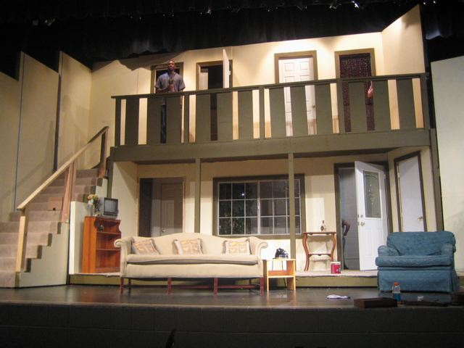

**TECH AWARDS**

**SET DESIGN**

Set Design 2017

Ray Persing

Noises Off

The Drama Workshop

**Noises Off** - The Drama Workshop **(Overall Winner)**

Outstanding in Overall Set Design - Ray Persing

Outstanding in Concept - Ray Persing

Outstanding in Special Design - Ray Persing

Outstanding in Use of Space - Ray Persing

Excellence in Use of Color & Materials- Ray Persing

**I Love You, You're Perfect, Now Change**, Loveland Stage Company

Excellence in Overall Design – Michael Kiser

Excellence in Period Definition - Michael Kiser

Merit in Use of Color & Materials - Michael Kiser

Merit in Concept - Michael Kiser

**Thumbs**, Hudson Players

Excellence in Overall Design - Todd Plone

Excellence in Use of Space - Todd Plone

Outstanding in Specific Design Element (Fireplace) - Todd Plone

Merit in Use of Color & Materials - Todd Plone

**Lighting Design**

Excellence in Lighting Design - Julie Lane, Ft Findlay Playhouse

Excellence in Lighting Execution - Jordan Gottschalk & Vashti Larson, Ft Findlay Playhouse

**Costume Design**

Costume Design 2017

The Lion King Jr.

Waterville Playshop

**A Funny Thing Happened on The Way To The Forum,** Loveland Stage Company

Outstanding in Overall Costume Design - Carissa Griffith

Outstanding in Attention to Detail - Carissa Griffith, Carolyn Finn, Jessica Kehoe, Tom Morris

Outstanding in Use of Color - Carissa Griffith, Carolyn Finn, Jessica Kehoe, Tom Morris

Excellence in Use of Patterns and Texture - Carissa Griffith, Carolyn Finn, Jessica Kehoe, Tom Morris

Excellence in Costume Fitting - Carissa Griffith, Carolyn Finn, Jessica Kehoe, Tom Morris

**The Lion King, Jr.,**The Waterville Playshop  (**Overall Winner)**

Outstanding in Overall Costume Design - Michelle S. Johnson

Outstanding in Authenticity - Michelle S. Johnson, Tammy Fitch, Joe Barton, Trevor Gill-Snow, Brooke Dove, Abby Fitch, Shannon Ruhe, Lacey Bodette

Outstanding in Detail - Michelle S. Johnson, Tammy Fitch, Joe Barton, Trevor Gill-Snow, Brooke Dove, Abby Fitch, Shannon Ruhe, Lacey Bodette

Outstanding in Use of Pattern & Texture - Michelle S. Johnson, Tammy Fitch, Joe Barton, Trevor Gill-Snow, Brooke Dove, Abby Fitch, Shannon Ruhe, Lacey Bodette

Excellence in Use of Color - Michelle S. Johnson, Tammy Fitch, Joe Barton, Trevor Gill-Snow, Brooke Dove, Abby Fitch, Shannon Ruhe, Lacey Bodette

Excellence in Use of Masks & Handhelds - Michelle S. Johnson, Tammy Fitch, Joe Barton, Trevor Gill-Snow, Brooke Dove, Abby Fitch, Shannon Ruhe, Lacey Bodette

**The Glass Slipper**, Central Ohio Family Theatre

Excellence in Overall Costume Coordination - Aara Wise

Excellence in Use of Color - Aara Wise

Excellence in Costume Fitting - Aara Wise

Merit in Individual Costume Design - Aara Wise, for the Cat & Mouse.

**Website Design Trophy & Certificates**

Overall Website 2017

Dave Bauer

Loveland Stage Company

**WEBSITE FUNCTIONALITY:**

Loveland Stage Company – Outstanding in Website Functionality (20)

Fort Findlay Playhouse - Outstanding in Website Functionality (19)

Toledo Repertoire Theatre – Excellence in Website Functionality (16)

**WEBSITE DESIGN:**

Loveland Stage Company / Dave Bauer – Outstanding in Website Design (20)

Fort Findlay Playhouse / Jr Smith - Outstanding in Website Design (19)

Toledo Repertoire Theatre / Anita Crane – Merit in Website Design (12)

**WEBSI** **TE CONTENT:**

Loveland Stage Company – Outstanding in Website Content (20)

Fort Findlay Playhouse - Outstanding in Website Content (20)

Toledo Repertoire Theatre – Excellence in Website Content (17)

**WEBSITE ORIGINALITY:**

Loveland Stage Company – Outstanding in Website Originality (19)

Fort Findlay Playhouse - Outstanding in Website Originality (19)

**WEBSITE PROFESSIONALISM & EFFECTIVENESS:**

Loveland Stage Company – Outstanding in Website Professionalism & Effectiveness (18)

Fort Findlay Playhouse - Excellence in Website Professionalism & Effectiveness (16)

Toledo Repertoire Theatre - Merit in Website Professionalism & Effectiveness (14)

**WEBSITE OVERALL:**

Loveland Stage Company / Dave Bauer (SW) – Outstanding in Overall Website (97)

Fort Findlay Playhouse / JR Smith (NW) - Outstanding in Overall Website (93)

Toledo Repertoire Theatre / Anita Crane (NW) – Merit in Overall Website (67)

**Newsletter Certificates**

**Shirley Nebergall, Editor**

**Fort Findlay Playhouse’s *The Fortell –* 1st Place Overall Newsletter Design**

Outstanding in Writing & Overall Quality

Outstanding in Masthead Design & Layout

Excellence in Use of Graphics & Photography

Excellence in OCTA News

**Michael Ritzert & Kathleen Gray Farthing, editors**

**Carnation City Players’ *CC People***

Excellence in Masthead Design & Overall Quality

Excellence in Use of Graphics & Photography

Excellence in Writing

**Erin O’Neill, editor**

**Mid-Ohio Valley Players’ *Entr’ Acte***

Excellence in Masthead & Overall Quality

Excellence in Use of Photography & Writing

**Millie Butts, editor**

**Playmakers Civic Theatre’s *Theatre Talk***

Excellence in Masthead Design, Layout, & Overall Quality

MC900239011[1] Excellence in Use of Photography & OCTA News

Merit in Use of Graphics

**Charlie Hupp, editor**

**Licking County Players’ *The Curtain Call***

Excellence in Masthead Design & Layout

Merit in Overall Quality and OCTA News

Merit in Use of Graphics and Photography

**Sarah Sobel-Poage, editor**

**The Toledo Repertoire Theatre’s *The REPorter***

Outstanding in Use of Graphics and Photography

Excellence in Masthead Design, Layout, & Overall Quality

Merit in Writing and Creativity

**Brochure Competition**

Best in Show Brochure 2017

Carnation City Players

Outstanding in Overall Design Excellence in Overall Design Merit in Overall Design

Mariemont Players Fort Findlay Playhouse Centerstage Players

Village Players Sunset Players Greater Hamilton Civic Theatre

The Toledo Repertoire Theatre The Drama Workshop OH Community Theatre Association

The Footlighters, Inc.

**Patron Plaques** (Given for the previous fiscal year)

**2016 2016**

OCTA Patron Program OCTA Patron Program Leader

Most Improved Northwest Region

Central Region

**Art Rouse Attendance Plaque**

Waterville Playshop - NW Region

**Hall of Fame 2017 Inductees**

Mark & Betty Peters - Columbus, OH

Arny Stoller – Cincinnati, OH

Syd Spate – Toledo, OH

**President’s Award**

Michelle Johnson

**Special Recognition Award**

**LIFETIME MEMBER OCTA 2017**

Michael Schacherbauer

**OCTAFest Chair – Annual Report 2018**

During the 2017-18 program year, our Guide/Respondent Program was placed under the administration of the OCTAfest Chair. The program was used only twice, a significant decrease from last year’s 12 sessions. As a piece of its OCTA membership, each theatre has two opportunities to use this educational program to enhance its efforts in producing quality live theatre in our state.

2018 was an exciting year for our Regional Festivals. Between June 2 and July 8, forty-one theatres excerpted at festivals in our six regions, representing a 28% increase over last year’s participation. Three of five new works performed at our regionals were included in the 12 theatres who earned a trip to the State Conference. Alternates from the NW and SE regions were invited to fill the 14 excerpt slots at Conference. All regional awards are posted at www.octa1953.org under the heading “More” and its drop-down menu of region names.

Special thanks to the regional reps and volunteers who organized festivals: Central: Kenyon College (MTV Arts); Northwest: Owens Community College Center for Fine and Performing Arts (NW Members); Northeast: Barlow Community Center (Hudson Players); Southwest: Parrish Auditorium (ACT of Cincinnati); Southeast: Roscoe Village (Coshocton Footlighters); and West: Beavercreek Community Theatre.

Eight people took part in Responder Training at the 2017 State Conference, and several were used as a part of this year’s Responder Team. A special thank you to this year’s group of Responders who traveled the state to offer feedback to our performing groups: Joe Barton, Theresa Benyo-Marzullo, DeeAnn Bryll, Ed Cohen, John Falkenbach, Gladys Haney, Denver Henderson, Kathy Hyland, Inge Klopping, Dan Maloney, Susan Metz-Guthrie, Stayce Nabors, Patricia Potter, Lisa Sommers, Deb Wentz, and Brian Westerley.

Respectfully submitted,

Michelle JohnsonDan Maloney

2018 OCTA Fest Co-Chair 2018 OCTA Fest Co-Chair

**2018 REGIONAL REPORTS & AWARDS**

**Central Region**

The Central Region Festival was held on June 2, 2018 at Kenyon College in Gambier.

It was hosted by MTVarts. There were seven (7) theatres that presented excerpts. They

included *Joseph and the Amazing Technicolor Dreamcoat*(Bucyrus Little Theatre),

*Wendy Darling*(Curtain Players), *Glass*(Eclipse Theatre Company), *Almost, Maine*(Licking County Players), *Dancing on Clouds*(Mount Vernon Players), *Harvey*(Out Of The Box Community Theatre) and *Psych*(Little Theatre Off Broadway).

Licking County Players was the recipient of this year’s Spirit of Community Theatre award.

There was a short delegates meeting held during the festival. At that time, Timothy Pierce was re-elected as a Region Representative for 2018-2019. Timothy will continue as the Central Region Lead Representative. Gladys Haney was elected as a new Region Representative for Central Region for 2018-2019.

Respectfully and Thankfully submitted by,

Timothy Pierce, Central Region Lead Representative

**Central Region Awards**

***HARVEY***

Christopher Seitz – Excellence in Acting as Dr. Chumley

John Pythyon -Merit in Acting as Lofgren

***WENDY DARLING***

The Cast – Outstanding in Ensemble

Tasha Naneth – Excellence in Costuming

Heather Schultz – Outstanding in Direction

Elizabeth Harelik - Excellence in Acting as Wendy

Cody Schmid – Outstanding in Acting as Peter Pan

Jeff Kemeter – Merit in Acting as Smee

Randy Benge – Excellence in Acting as Captain Hook

Neil Aring – Excellence in Set Design

***JOSEPH AND THE AMAZING TECHNICOLOR DREAMCOAT***

Ryan Shealy – Merit in Direction

Sheila Holloway – Excellence in Musical Direction

The Cast – Excellence in Vocal Ensemble

Peter Henkels – Excellence in Vocal Performance as Joseph

Sydney Harris & Mary Faulds– Merit in Vocal Performance as Narrators

The Cast – Excellence in Ensemble Acting

***GLASS***

Jim McCullough – Excellence in Costumes & Makeup

Greg Smith – Excellence in Hair Design

Greg Smith – Outstanding in Direction

Greg Smith – Outstanding in Set Design

Nick Samson – Outstanding in Acting as Tennessee Williams

Kathy Sturm – Outstanding in Acting as Laurette Taylor

The Cast – Outstanding in Ensemble

***ALMOST, MAINE***

Bill Sweeney – Excellence in Acting as Phil

Barbe Helwig – Excellence in Acting as Hope

Brandie Salierno – Merit in Acting as Marci

Russ Connor – Merit in Acting as Dan

Jessica Nincehelser – Excellence in Acting as Rhonda

Destin Richardson – Merit in Acting as Dave

***DANCING ON CLOUDS***

Bill Bridges – Merit in Acting as Edwin

Ira Mowery – Merit in Original Script

***PSYCH***

Kate Charlesworth-Miller – Excellence in Acting as Lydia

The Cast – Merit in Ensemble

Michael Evanichko – Merit in Acting as Robert/Sam

Donnie Lockwood – Merit in Acting as Edward

**INVITEES**

GLASS

WENDY DARLING

**ALTERNATE**

JOSEPH AND THE AMAZING TECHNICOLOR DREAMCOAT

**Northeast Region**

The Northeast Region Delegates meeting was held April 28, 2018 in Green hosted by

Theatre 8:15. Board members Dawna Kornick, Wayne Kirsch, and Susan Barzda also attended the meeting. They discussed the need for support for the Regional Reps, the Redistricting proposal, and the upcoming regional. The walk-the-stage meeting was held on May 6, 2018 in Hudson. The Northeast Regional was held on Saturday, June 16, 2018 hosted by the Hudson Player at the Barlow Community Center, 41 S. Oviatt St., Hudson, Ohio 44236. There were 5 theatres excerpting, selected to perform at State Conference were Chagrin Valley Little Theatre “The Underpants”, Western Reserve Playhouse “Tomorrow Morning” and Hudson Players “Nunsense” was chosen as the alternate. Regional Reps elected for 2018-19 were Tammy Carder, Sue Cohen, Sue Snyder and Deb Wentz.

Submitted by Dawna Kornick, NE OCTA Board Member

**Northeast Region Awards**

***THE DINNING ROOM***

The Cast – Merit in Children’s Ensemble

Tammy Carder – Merit in Acting

Ron Church – Merit in Acting

***THE UNDERPANTS***

Lisa Freebairn – Outstanding in Acting as Gertrude

Laurel Bryant – Excellence in Directing

The Cast – Excellence in Ensemble

Laurel Bryant – Outstanding in Set Design

Emmy Cohen – Excellence in Acting as Louise

Barry Moses – Merit in Acting as Theo

Christian Achkar – Excellence in Acting as Versati

Wes Roj – Excellence in Acting as Cohen with a “K”

Laurel Bryant – Merit in Costumes

***TOMORROW MORNING***

Bryan Bird – Outstanding in Musical Direction

Michael Snider – Excellence in Musical Theatre Performance as Jack

Madeline Krucek – Outstanding in Musical Theatre Performance as Kat

Tony Heffner – Excellence in Musical Theatre Performance as John

Dawn Sniadak-Yamokoski – Excellence in Musical Theater Performance as Catherine

***MOONLIGHT AND MAGNOLIAS***

John Capocci – Merit in Acting as Ben Hecht

Coach House Theatre – Merit in Set Décor

***NUNSENSE***

Chanda Porter – Merit in Choreography

Shelly Palumbo – Excellence in Musical Theater Performance as Sister Mary Hubert

The Cast – Excellence in Musical Theater Ensemble

Carri Wagner – Merit in Musical Theater Performance as Sister Robert Anne

Sharon Lloyd – Merit in Musical Theater Performance as Sister Mary Regina

Jessica Defrange – Merit in Musical Theater Performance as Sister Mary Amnesia

Macey Staninger– Merit in Musical Theater Performance as Sister Mary Leo

Dave Stebbins – Merit in Musical Direction

**INVITEES**

THE UNDERPANTS

TOMORROW MORNING

**ALTERNATE**

NUNSENSE

**Northwest Region**

The Northwest delegates met 4 times throughout the year with 3B Productions hosting a soup and salad luncheon and The Village Players of Toledo welcomed delegates twice with coffee and doughnuts. Waterville Playshop also was scheduled for a meeting, but last-minute scheduling conflicts forced that to relocated. The Walk the Stage meeting was held at the festival site, Owens Community College Center for Fine and Performing Arts during year 2 of a 3-year commitment to host in this state of the art beautiful and comfortable venue. Current membership is 22 theatres, while 5 theatres were lost to the roster, 3 because of inactivity, they gained one new theatre, welcomed one back after a year of inactivity and have several others who are considering joining. The NW theatres continue to actively use the Guide/Respondent program and encourage member theatres to participate in state level competitions. Reps actively use Facebook and the regions own website (octanorthwest.com) to promote members auditions, performances and events. At the regional festival, 3 returning reps were joined by 3 new enthusiastic volunteers. As the festival continues to grow, work has begun to divide duties and responsibilities as they continue to strive for the best event possible. Several major fundraising and fun social events are being planned for the region that will also be open to the entire state to share in the fun. Working together the region continues to uphold its motto of “The Best Comes from the Northwest”

Submitted by Mitchell Antesky, Lead Rep.

**Northwest Region Awards**

***ALMOST, MAINE***

Christa Manning – Merit in Acting as Deena

Lauren Spyker – Merit in Acting as Marci

Rebecca Gamble – Merit in Acting as Rhonda

Jeff Kerr - Merit in Sound Design

***SQUABBLES***

Phil Johnson – Merit in Acting as Hector

The Cast – Merit in Ensemble

Donna Jean Evans – Excellence in Directing

Kate Volz – Excellence in Set Design

Jim Brokaw – Outstanding in Acting as Abe

Jennifer Wertz – Excellence in Acting as Mildred

Mindi Bishop – Merit in Costumes

***THE GREAT AMERICAN TRAILER PARK MUSICAL***

Jerry Zimmerman – Outstanding in Directing

Jerry Zimmerman – Outstanding in Choreography

Dee Fisher – Outstanding in Musical Direction

The Cast – Merit in Costumes

Little Theatre Off Broadway – Excellence in Set Design

Kristin Lee/Kara Place/Stacy Rife – Excellence in Trailer Park Trio

The Cast – Merit in Ensemble

Mary Ann Falk – Merit in Wig Design

Kristin Lee – Excellence in Musical Theatre Performance as Betty

Mary Ann Falk – Merit in Musical Theatre Performance as Jeannie

The Musicians – Excellence in Orchestral Performance

***THE 25TH ANNUAL PUTNAM COUNTY SPELLING BEE***

The Cast – Excellence in Ensemble for Musical Theater Performance

Nathan Wright – Outstanding in Vocal Performance as Mitch

Nathan Wright/Lauren Deporre/Cayla Kale-Excellence in Ensemble for Vocal Performance-“I Love You” Trio

Joe Barton – Merit in Directing

Janine Baughman – Excellence in Musical Direction

The Cast/3B Costumes – Merit in Costumes

The Musicians – Merit in Orchestral Performance

Sarah Pettee – Merit in Musical Theatre Performance as Logainne

***ROMANTIC COMEDY***

Margaret Helbing – Merit in Acting as Blanche

Nadine Jensen – Merit in Costumes

***MONTY PYTHON’S SPAMALOT***

Mark Williams – Merit in Choreography

Dave Fitch – Merit in Set Design

Lauren Deporre – Merit in Musical Theatre Performance

Shannon Ruhe/Joe Barton/Joyce Coutinho – Merit in Ensemble for Frenchie Trio

***THE LAST FIVE YEARS***

Rhianon Barlos – Outstanding in Musical Theatre Performance as Catherine

Michael Barlos – Outstanding in Musical Theatre Performance as Jamie

Stephanie Dennehy – Outstanding in Directing

Todd Schreiber – Outstanding in Musical Direction

Stephanie Dennehy & Joe Dennehy – Outstanding in Set Design

Stephanie Dennehy – Outstanding in Lighting Design

Michael Barlos & Rhianon Barlos – Merit in Costumes

***ON GOLDEN POND***

The Cast – Merit in Ensemble

Bob Welly – Excellence in Acting as Norman

Gavin Miller – Merit in Acting as Billy

Fran Morton – Excellence in Acting as Ethel

Thomas Edge – Excellence in Acting as Bill Sr.

Stephanie King Truman – Merit in Acting as Chelsea

Wayne G. Weber – Merit in Directing

***HANDS ON A HARD BODY***

Chelsie Cree – Excellence in Acting as Janis

Clark Ausloos – Excellence in Directing

Michael Kadin Craig – Excellence in Musical Direction

The Cast – Excellence in Ensemble Musical Theatre Performance

Ward Ensign – Excellence in Musical Theatre Performance as Benny

Kristin Kukic – Excellence in Musical Theatre Performance as Heather

Amanda Reisner – Excellence in Musical Theatre Performance as Norma

Clark Ausloos – Merit in Choreography

Julie Bermudez – Merit in Costumes

Brendan Coulter – Merit in Musical Theatre Performance as Chris

Chris Stack – Merit in Musical Theatre Performance as Mike

***TITLE OF SHOW***

The Cast – Excellence in Ensemble Musical Theatre Performance

Daniel Bradshaw – Excellence in Musical Theatre Performance as Jeff

Wes Vollmar – Excellence in Musical Theatre Performance as Hunter

Amanda Zucker – Merit in Musical Theatre Performance as Susan

Hannah Mathias – Merit in Musical Theatre Performance as Heidi

Jim Besch – Merit in Musical Accompaniment

Charles Groth – Excellence in Directing

Amanda Zucker – Merit in Choreography

Mandy Bour – Merit in Props

***A LIFE***

John Duvall – Outstanding in Acting as Nate Martin

Actors Collaborative Toledo – Excellence in Set Design

Jeffrey J. Albright – Outstanding in Directing

**INVITEES**

THE LAST FIVE YEARS

A LIFE

HANDS ON A HARD BODY

**ALTERNATE**

THE GREAT AMERICAN TRAILER PARK MUSICAL

**Southeast Region**

The Southeast Regional Representatives for the 2017-2018 year were Janie Mancini, Linda Smith, Sally Holmes, and Billie Harmon.   Delegate meetings were held on October 14, 2017 in Jackson, Ohio; and November 11, 2017 and January 27, 2018 at The Forum Restaurant in Cambridge, Ohio;  on March 24, 2017 at Jeremiah's  Coffee  House  in Marietta, Ohio, and on May 26, 2018 at the venue for the Southeast Regional in Roscoe Village at the Triple  Locks Theatre, the home of the Coshocton  Footlight Players.   A meeting was also held at that location during the June 30, 2018 Regional.  During their meetings, delegates discussed themes for the regional and encouraged participation in the regional.  The Regional Reps went to Apple City Players to watch Four Weddings and an Elvis; to Cambridge Performing Arts Centre to view a performance based on Sherlock Holmes; to Mid-OhioValley Players to view One Flew Over the Cuckoo's Nest, and to Zanesville Community Theatre to view Grey Gardens. The delegates discussed the need for members of Southeast Theatres to assist with the 2018 conference duties, getting show dates listed on the callboard, and plans for the Southeast Regional. They discussed having excerpting theatres bring a basket to raffle, and to bring an item to put in the regional basket for OCTA’s Silent Auction, and designs for the regional T-shirts.  The theme for the Regional was "Rockin' in Coshocton".

First Vice-president Wayne Kirsch attended a meeting and provided information on the Redistricting proposals, which will be voted on at the Annual Delegates Meeting at the State Conference.  Conference Chair John Falkenbach attended a meeting to give expectations and responsibilities for our region to assist at state conference. At the June 30 meeting areas of concern were the low participation level of the region’s theaters in the Regional festival, and the need to update contact information for member theaters’ delegates.   The region then voted to elect Linda Smith, Janie Mancini, and Sally Holmes as Southeast Regional Reps for 2018-2019.  During our regional The *Savannah Sipping Society* by Coshocton Footlight Players was selected to represent the Southeast Region at the State Conference, and *Cat on a Hot Tin Roof* by The Little Theatre of Tuscarawas County was selected as the Alternate.  Both groups will perform at the State Conference this year.   Kait Gallagher-Wilsterman was honored with the Southeast Spirit of Community Theatre Award for 2018.

Submitted by Susan Barzda, SE Board Member

**Southeast Region Awards**

***THE SAVANNAH SIPPING SOCIETY***

Kathy Reid – Excellence in Acting as Dot

Ellen Hardesty – Merit in Acting as Jinx

Nathan Mayse – Merit in Directing

***CAT ON A HOT TIN ROOF***

Connor Mast – Excellence in Acting as Brick

Dave Cleveland – Excellence in Acting as Big Daddy

**INVITEE**

THE SAVANNAH SIPPING SOCIETY

**ALTERNATE**

CAT ON A HOT TIN ROOF

**Southwest Region**

The Southwest Region held meetings at St. Rita’s School on September 26th, October 24th, November 28th, January 23rd, February 27th, March 27th, April 24th, and May 22nd, and at Footlighters Inc. on June 26th.

At each meeting, the deadlines for the various OCTA awards were discussed—Hall of Fame, Spirit of Community Theater, Scholarships, and Competitions. The dates of the regional convention and state conference were mentioned at every meeting.

Also, at every meeting, it was mentioned that future state conferences after 2018 will have the excerpts presented in a theater rather than a temporary stage set up in a hotel ballroom.

After several reports of “We haven’t been receiving our OCTA mail”, every group received a new Theatre Information Form to be filled out and sent to the Administrative Assistant. This included the groups that said they had “no changes”.

At the March 27th meeting, each group that had paid its dues received its packet for the June 2018 regional convention. The three groups that had not paid their dues were notified and reminded several times. Each paid in time to be permitted to present an excerpt.

At the February meeting, we discussed the rules for excerpting in order to try to minimize last minute confusion. We recognize that you can’t completely avoid issues, only minimize them.

The redistricting proposals to be voted on at the state conference were discussed, often fervently. While Southwest would be affected less than other regions, there was concern from the Warren County groups that they would be switched to another region involuntarily. Once it was established that a group may request to remain in its previous region should a redistricting occur, the discussion became far less animated.

Two new groups were voted in by the OCTA Board as new member theaters for 2018—Innova Theatre and Merit Theatre. Innova presented an excerpt at the June regional.

The 2018 Southwest Regional was held on June 21-22-23 at our regular location, Parrish Auditorium at Miami University-Hamilton, with 376 attendees. Thirteen groups presented excerpts—Beechmont Players, Cincinnati Music Theatre, The Drama Workshop, Sunset Players, Innova Theatre, Milford Theatre Guilde, Loveland Stage Company, Village Players, Tri-County Players, CenterStage Players, Footlighters Inc., Stagecrafters Inc., and Mariemont Players. The excerpts chosen to be presented at the state conference on September 1-2 are CenterStage Players’ *Tribes*, Mariemont Players’ *Around the World in 80 Days,* and Footlighters Inc.’s *Jekyll and Hyde.* The alternate is The Drama Workshop’s *The Girls of Miller’s Court*.

Dan Maloney received the region’s Spirit of Community Theater award.

At the June 26th meeting, the region’s five regional representatives were voted in to serve for another year—Kevin Noll, Amy Sullivan, John Masterson, Cindy Emmer, and Ray Lebowski.

The regional representatives’ goals for 2018-19 remain the same—To meet with as many groups’ boards as possible to discuss how OCTA can help them, to encourage their participation at the regional convention, to attend as many groups’ shows as possible, and to seek out potential new member groups.

Submitted by Ray Lebowski, Lead Region Rep.

**Southwest Region Awards**

***MOON OVER BUFFALO***

Karson McCall - Merit in Acting as Rosalind

Stephen Beck – Merit in Acting as Howard

Linda Roll – Merit in Costuming

***TRIBES***

Alan Kootsher – Excellence in Acting as Christopher

Kathy Labanz – Excellence in Acting as Beth

Ben Wright – Outstanding in Acting as Billy

Emma Kreiner – Outstanding in Acting as Sylvia

Victoria Kirby-Schnarber – Merit in Acting as Ruth

Richard Zenk – Merit in Directing

The Cast – Excellence in Ensemble

Chris Lee – Merit in Sound Design

***DON’T DRINK THE WATER***

Michael Kiser – Excellence in Acting as Father Drobney

Alex Ross – Merit in Acting as Axel Magee

Cathy Alter – Outstanding in Acting as Marion Hollander

Joel Lind – Outstanding in Acting as Walter Hollander

Morgan Carter – Merit in Acting as Susan Hollander

John Sloan – Merit in Directing

Carissa Sloan – Merit in Costuming

The Cast – Excellence in Ensemble

***WHEN WE ARE MARRIED***

Bryce Wilson – Merit in Acting as Gerald Forbes

Mark Metzner – Merit in Acting as Albert Parker

Linda Roll = Outstanding in Costuming

Gary Fruhwirth/Steve Phelan/Cathy Roesener – Merit in Set Design

Jim Percival – Excellence in Wig Design

***JAKE’S WOMEN***

The Cast – Excellence in Ensemble

Darren Lee – Excellence in Acting as Jake

Kaitrin McCoy – Excellence in Acting as Molly

Liz Koch – Excellence in Acting as Julie

Michael L. Moreland – Excellence in Direction

***FIVE WOMEN WEARING THE SAME DRESS***

The Cast – Merit in Ensemble

Allie Webber – Merit in Acting as Meredith

***THE GIRLS OF MILLER’S COURT***

Burt McCollom – Outstanding in Acting as James Archer

Russ McGee – Merit in Acting as Gaoler

Jef Brown – Excellence in Directing

Wayne Kirsch – Outstanding in Lighting Design

Jason Cox – Merit in Sound Design

The Girls Ensemble – Excellence in Ensemble

Jack Williams – Outstanding in Original Script

***STEEL MAGNOLIAS***

Lindsey Morgansen-Cardoza – Merit in Acting as Shelby

***JEKYLL AND HYDE***

The Orchestra – Outstanding in Orchestral Performance

Shawn Toadvine – Outstanding in Musical Theatre Performance as Jekyll/Hyde

Emily Martin – Outstanding in Musical Theater Performance as Lucy

The Vocal Quartet – Excellence in Vocal Performance

Taylor Isabel Winkleski – Merit in Musical Theater Performance as Emma

Amanda Emmons Shumate – Outstanding in Direction

Alan Masters – Outstanding in Musical Direction

Kate Stark – Merit in Choreography

Amanda Borchers & Josh Newman – Merit in Costuming

Forest Goodwin – Merit in Sound Design

Gene Waldron – Outstanding in String Performance

The Cast – Excellence in Ensemble

***BINGO! THE WINNING MUSICAL***

Amy Lee Waldfogle – Excellence in Acting as Vern

Laurie Brinkman – Merit in Acting

Megan Williams – Merit in Vocal Performance as Alison

Julie Theobald – Merit in Vocal Performance as Bernice

Cathy Lutts – Merit in Acting as Minnie

John Langley – Merit in Acting as Sam

Peggy Kenney – Merit in Directing

The Cast – Excellence in Ensemble

***ANGEL STREET***

Carrie Mees – Excellence in Acting as Bella

Erica Brady – Merit in Acting as Nancy

Jeff Carter – Merit in Acting as Rough

Amanda Borchers – Merit in Costuming

***AROUND THE WORLD IN 80 DAYS***

The Cast – Outstanding in Ensemble

Eric Day – Outstanding in Acting as Actor 1

Ryan Naish – Excellence in Acting as Actor 2

Jay Dallas Benson – Excellence in Acting as Actor 3

Patricia Mullins – Merit in Acting as Actor 4

Eric Thomas – Merit in Acting as Phileas Fogg

Patrick Kramer – Excellence in Foley Execution

Jerry Wiesenhahn – Outstanding in Direction

Sharon Shelton/Kristen Vincenty/Pam Kaesemeyer/Mary Kay Wiesenhahn – Merit in Costuming

Pam Kaesemeyer – Excellence in Props

The Cast – Excellence in Use of Props

***CAMELOT***

Rick Kramer – Outstanding in Musical Theater Performance as King Arthur

Sarah Viola – Outstanding in Musical Theater Performance as Guinevere

Dave Wilson – Outstanding in Musical Theater Performance as Lancelot

Chuck Ingram – Merit in Acting as Pellinore

The Cast – Excellence in Vocal Ensemble

Dennis Murphy – Excellence in Direction

Kathy Kramer – Excellence in Vocal Direction

**INVITEES**

TRIBES

AROUND THE WORLD IN 80 DAYS

JEKYLL AND HYDE

**ALTERNATE**

THE GIRLS OF MILLER’S COURT

**West Region**

The West Region held meetings on November 18 at Beavercreek Community Theatre, March 24 hosted by Troy Civic Theatre; and June 18 at Beavercreek Community Theatre.

At the November 18 meeting, Al Yarko introduced himself as the new executive director of Actors Theatre of Fairborn and John Falkenbach also noted that Springfield Civic Theatre is doing a production and might be another new West theater.

Christi and Niccole have divided up the West theaters and noted that it’s not too early to start thinking about competitions, scholarships, Hall of Fame, and Spirit of Community Theatre awards, and briefly talked about the 2018 Conference and the possibility of redistricting.

Christi encouraged everyone to use the Guide/Respondent program and ways to encourage theaters to excerpt, especially since this is an AACT year.

At the March 24 meeting, theater packets were distributed to the delegates present and questions were answered about the excerpting process. New portions of the rules were discussed. There are currently 3 possible excerpts for the July 8 festival. It was decided that the registration fee would stay at $15 this year.

Also discussed were the deadlines for the Spirit of Community Theatre, Hall of Fame, and Scholarships, as well as the competitions deadline of July 21. Forms are on OCTA’s website. John handed out papers and held a discussion about OCTA Conference 2018.

Niccole handed out copies of the two drafts of the Redistricting proposal. This will be voted on at the annual Conference.

Actors Theatre of Fairborn was voted in by the OCTA Board as a new member theater for 2018. We hope they will excerpt in July.

The 2018 West Regional was held on July 8 hosted by Beavercreek Community Theatre with three theaters excerpting and 65 attendees. Excerpts were from Beavercreek Community Theatre, Xenia Area Community Theatre, and Troy Civic Theatre. Troy’s excerpt of *Escanaba in da Moonlight* will represent the West at the Annual Conference in Columbus Labor Day weekend with Beavercreek’s *A Streetcar Named Desire* as the alternate.

Sonja Hyer of Troy Civic Theatre received the OCTA Spirit of Community Theatre award.

Niccole Amersdorfer and Christi Thomas will continue to be the Regional Reps for the West Region for the next year.

Christi continues to send out the region’s newsletter, *West Wings*, by email to keep everyone informed of all the happenings in the West Region and with OCTA and Niccole updates FACEBOOK frequently.

The West Region Reps’ goals for 2018-19 are to continue to attend more theater productions in the area, encourage more theaters to excerpt, and possibly add another new member theater.

Submitted by Christi Thomas, West Region Lead Rep.

**West Region Awards**

***THE LAST OF THE RED HOT LOVERS***

Connie Strait & Debra Zweber– Merit in Costumes

Nathan Hudson - Merit in Acting as Barney Cashman

Christy Carson – Merit in Acting as Bobbi Michele

The Cast – Merit in Ensemble

Connie Strait & Debra Zweber– Merit in Props

***ESCANABA IN DA MOONLIGHT***

The Cast – Outstanding in Ensemble

Chuck Fox – Outstanding in Direction

Steve Dietrich & Chuck Fox – Excellence in Set Design

Sonja Hyer – Outstanding in Props

Scott Atkinson – Outstanding Acting as Jimmer Negamanee

Michael Maxson – Merit in Acting as Albert Soady

Paul E. Robinson – Excellence in Acting as Remnar Soady

Todd E. Bryant – Merit in Acting as Reuben Soady

Jason Johnston – Merit in Acting as Ranger Tom T. Treado

The Cast – Excellence in Costuming

The Cast – Excellence in Use of Dialect

Jennifer Kaufman – Merit in Sound Design

***A STREETCAR NAMED DESIRE***

Jeff Sams – Outstanding in Directing

John Falkenbach – Excellence in Light and Sound Design

Ara Beal – Merit in Props

Chris Harmon – Merit in Set Design

The Cast – Excellence in Ensemble

Adee McFarland – Outstanding in Acting as Blanche Du Bois

Zach Katris – Excellence in Acting as Stanley Kowalski

Jeff Sams – Excellence in Acting as Mitch

Heather Atkinson – Merit in Acting as Stella Kowalski

Jeff Sams & The Cast – Outstanding in Fight Choreography

Terry Larson – Merit in Acting as Eunice

**INVITEE**

ESCANABA IN DA MOONLIGHT

**ALTERNATE**

A STREETCAR NAMES DESIRE



**SPIRIT OF COMMUNITY THEATRE AWARDS**

**2018**

Central Region Licking County Players

Northwest Region Toledo Repertoire Theatre

Southeast Region Kait M. Gallagher-Wilsterman

Southwest Region Dan Maloney

West Region Sonya Hyer

**\*\*\* 2018 Scholarship Winners \*\*\***

Larry Weber Scholarship $500.00 – Morgan Reece

Fred Wise Memorial Scholarship $500.00 – McCartney Betz

Patron Scholarship $500.00 – Rebecca Buck

Patron Scholarship $500.00 – Rafael Pacheco

**Thank you to our generous Individual donors and Patrons for believing in education enough to continuously provide scholarships for those young people interested in continuing the pursuit of theater. Without your generosity this would not be possible!**



[This Photo](https://houseofgimp.deviantart.com/art/Theatre-Masks-Tattoo-Design-194045122) by Unknown Author is licensed under [CC BY-NC-ND](https://creativecommons.org/licenses/by-nc-nd/3.0/)



[This Photo](http://forsat3ml.blogspot.com/2013/12/2014-2015.html) by Unknown Author is licensed under [CC BY](https://creativecommons.org/licenses/by/3.0/)

**2018 STATE CONFERENCE PREVIEW**

Octa state Conference 2018 – OCTA ROCKS!, marks the beginning of OCTA’s 65th year.

This years’ conference is a first as it is sponsored by TWO regions. It was decided that this year’s conference be the joint venture of WEST and SOUTHEAST regions, thereby giving SouthEast a chance to contribute to the State Conference events planning. Co-Chairs for this year’s State Conference are West Region’s Christi Thomas and John Falkenbach and Southeast Region’s Susan Barzda. They have worked very hard with their Steering committee consisting of members of their respective regions toward planning an enjoyable and successful conference.

The main focus of the weekend, of course, will be presentation of the 14 excerpts chosen this year from the regional festivals. They will provide great entertainment and theatre and also showcase some unknown and/or new works.

Also, this weekend is scheduled numerous workshops and roundtables and social activities – just about something for everyone. The plans also include numerous late-night activities including Kamikaze Shakespeare, Bingo, Card & Board Games, a Euchre Tournament and of course MTI Singalong.

Friday Night begins with workshops and then a Welcome Pizza Party with Dance Lessons to learn some Rock & Roll Steps to go with the classic tunes. Following the pizza and dancing, NorthEast Region will then be hosting an opening night welcome party.

Saturday is the Annual Delegate’s Meeting and Election of Board Membes and then in the evening ROCK-A-PALOOZA tech competition. Teams of 4 will compete in events including Props, Costume Dressing and Theatre Trivia.

Sunday evening’s activities include the Banquet and Hall-Of-Fame induction. Following the banquet, there will be a Sock Hop and Costume Contest featuring favorite Rock Star & Rock Groups.

The weekend will conclude on Monday with Brunch, wrap up of the weekend events and presentation of awards.

Thanks to all who has assisted with the preparation and execution of the weekend activities. The fun and theatrical comradery should serve as a great beginning to OCTA’s 65th year.

OCTA ROCKS!

Respectfully submitted,

John Falkenbach,

2018 State Conference Co-chair

OCTA

ROCKS!

State Conference

2018

**OCTA’S HALL O F FAM E HONOREES**

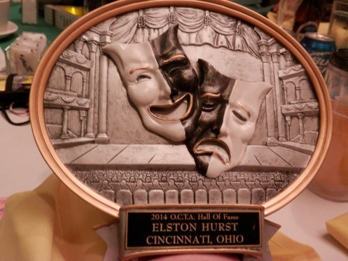

**HALL O F FAME INDUCTEES – 2000 HALL O F FAME INDUCTEES - 2001**

Jim Ponchot -- Southwest Region William Allman -- Northeast Region

Art Rouse -- Southwest Region Ohio Valley Summer Theatre 50 yrs.-SE Region

Robert W inters -- Southeast Region

**HALL O F FAME INDUCTEES – 2002 HALL O F FAME INDUCTEES - 2003**

Mary Haas -- Southwest Region G ene White -- Central Region

Bob Belfance -- Northeast Region Valerie G erstenberger -- Northeast Region

Janet Michel -- Northwest Region

**HALL O F FAME INDUCTEES – 2004 HALL O F FAME INDUCTEES - 2005**

Anne Matousek -- Northeast Region Cele Klein -- Northeast Region

Mary Beth Schulz -- Northeast Region Rondalee Derry -- Northwest Region

Patricia Shannon -- Central Region ACT-Cincinnati -- SW Region

**HALL O F FAME INDUCTEES – 2006 HALL O F FAME INDUCTEES - 2007**

Eleanor Smith -- Central Region Steve Haskins -- Southeast Region

Cecil W. G oldsmith -- Northwest Region Roger G rooms -- Southwest Region

G ib and Lou Reese -- Central Region Suzanne Bayley -- Southeast Region

**HALL O F FAME INDUCTEES – 2008 HALL O F FAME INDUCTEES - 2009**

Virginia Chizer - Southwest Region Eleanor Heyman - Northwest Region

Fred Wise - Central Region Dr. Donald Rosenberg - Southwest Region

Robert DeBenedictis - Central Region

**HALL O F FAME INDUCTEES – 2010 HALL O F FAME INDUCTEES - 2011**

Carol Mills - Southwest Region Sally Bowlin - Southwest Region

Sam Macera - Northwest Region The Mariemont Players, Inc. - SW Region

Michael Schacherbauer - Former Central Region Shirley G oldsmith - Northwest Region

**HALL O F FAME INDUCTEES – 2012 HALL O F FAME INDUCTEES - 2013**

Marilyn Stocker - Central Region John Lee -- Southeast Region

Ted & Jane Mixer - Central Region Williams Co. Comm. Theatre – NW Region

Waterville Playshop - Northwest Region

**HALL O F FAME INDUCTEES – 2014 HALL O F FAME INDUCTEES - 2015**

Elston Hurst -- Southwest Region Pat Furterer - - Southwest Region

Al & Jean Rodin -- Central & West Regions Harold Eisenstien - - Central Region

Reuben & Dorothy Silver -- Northeast Region

**HALL O F FAME INDUCTEES – 2016 HALL O F FAME INDUCTEES - 2017**

Willard Misfeldt - - Northwest Region Syd Spate - - Northwest Region

Dee Dunn - - Southwest Region Arny Stoller - - Southwest Region

Bob & Judy Slater - - Central Region Mark & Betty Peter - - Central Region

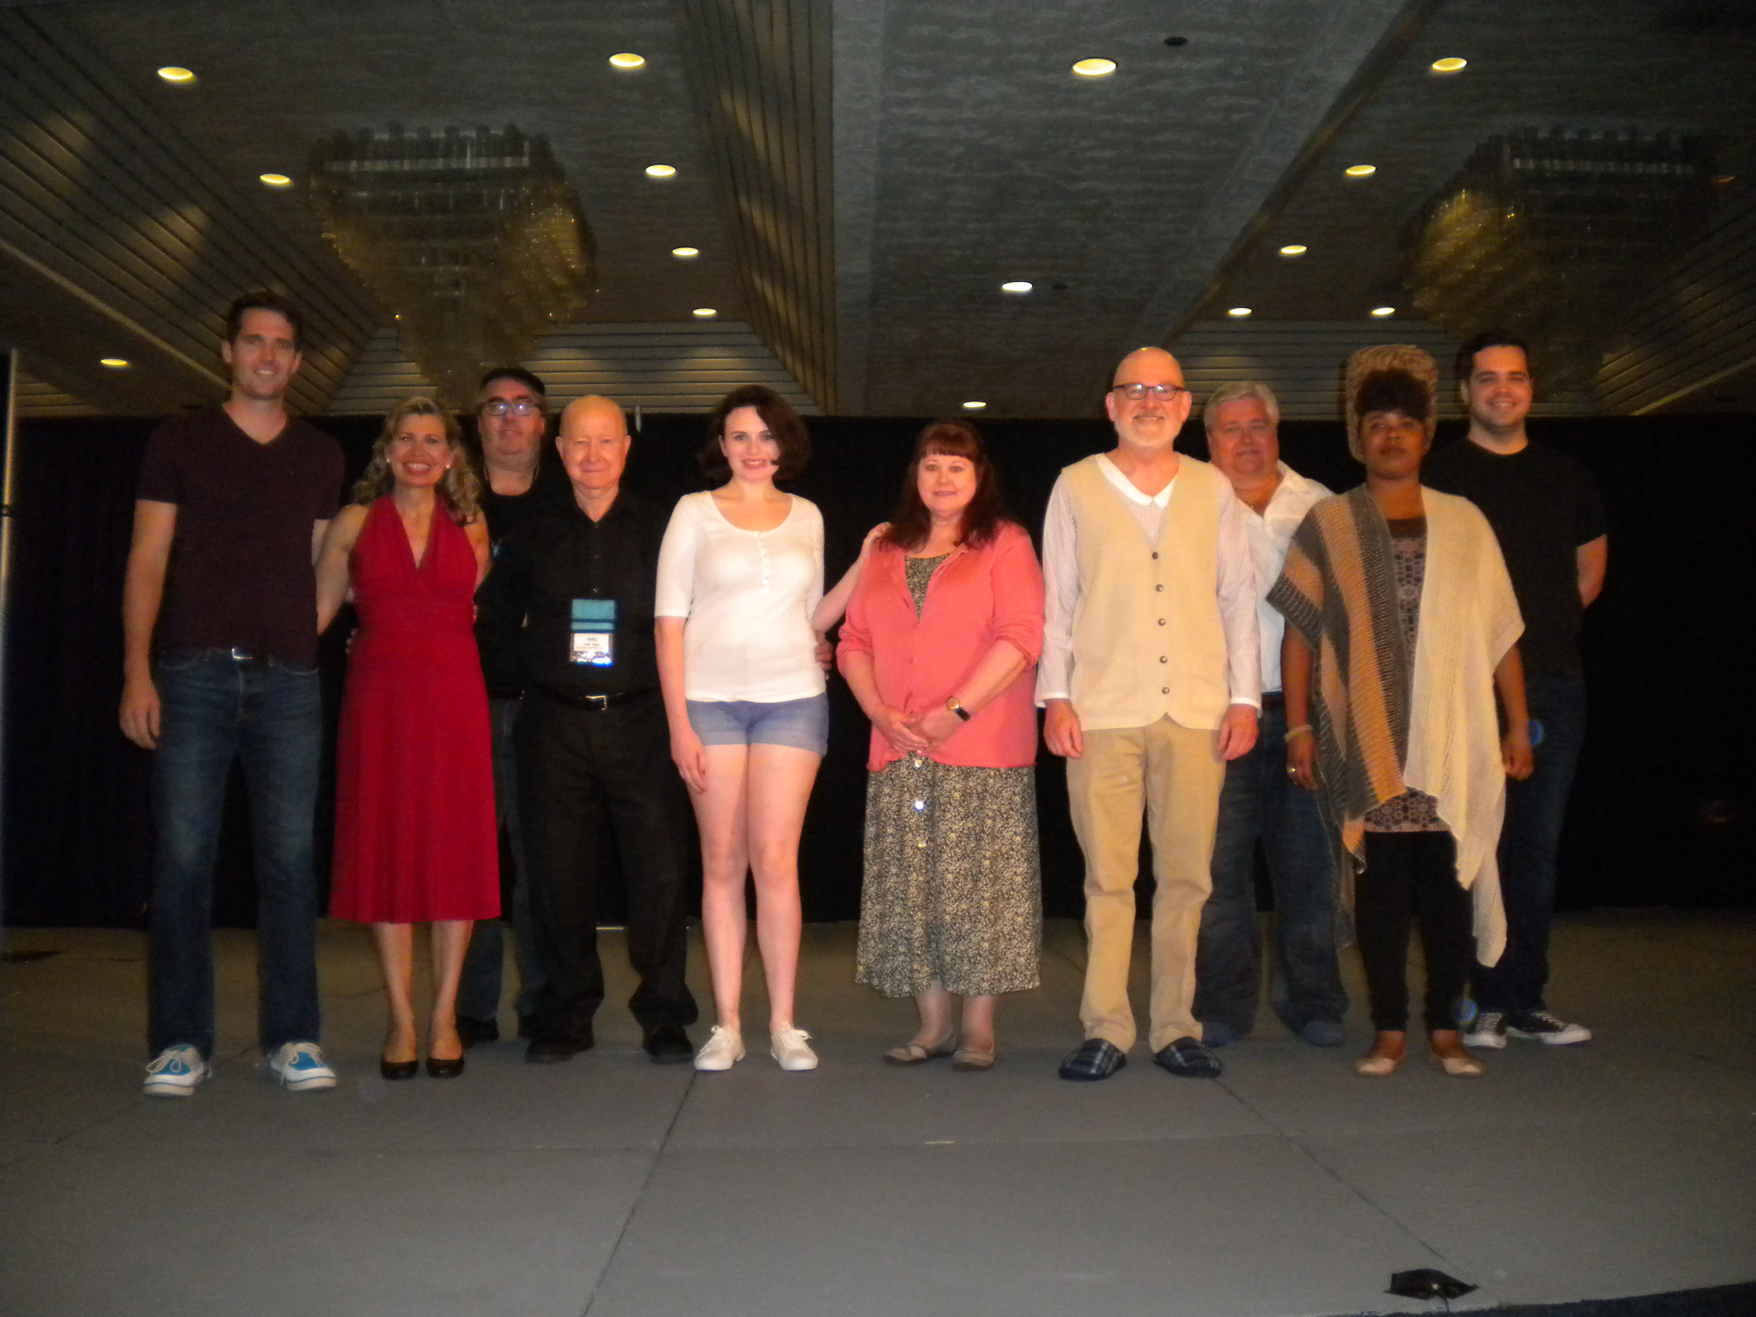

VANYA AND SASHA AND MASHA AND SPIKE

BEAVERCREEK COMMUNITY THEATRE

WEST REGION

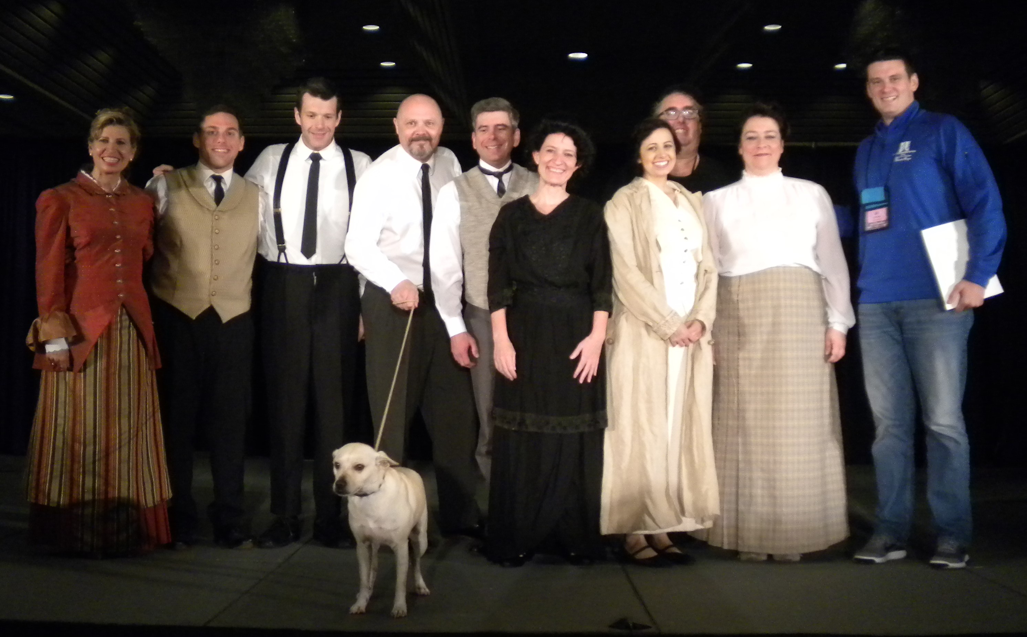

THE LAST LIFEBOAT

DAYTON THEATRE GUILD

WEST REGION

**Member Theatres & Listed Delegates by Region as of August 1, 2018**

Only delegates listed have the right to represent or vote for a member theatre unless written permission is received by the OCTA office.

**Central Region Delegates**

Bucyrus Little Theatre Jason Chandler

Chillicothe Civic Theatre Mike Ziogas

Curtain Players, Inc. Doug Browell

Eclipse Theatre Company Kathy Sturm

Galion Community Theatre No Delegate Listed

Licking County Players, Inc. Thom Ogilvie

Little Theatre Off Broadway Timothy Pierce

Mansfield Playhouse Doug Wertz

Mt. Vernon Players, Inc. Ira Mowery

MTVArts, Inc. Susan Moreland

Out of the Box CJ Jamison

Portsmouth Little Theatre No Delegate Listed

Roundtown Players Gary Gillen

The Lancaster Playhouse Loran Peterson

Worthington Community Theatre Jessica Schollenberger

**Northeast Region Delegates**

Broadview Heights Spotlights Tim Anderson

Brunswick Alumni Comm. Theatre Stayce Nabors

Carnation City Players Joan Conlon

Chagrin Valley Little Theatre Sue Cohen

Coach House Theatre Sergio Iriarte

Dynamics Community Theatre Kirsten Fitzgerald

Hudson Players Guild Inc. Michelle Dolciato

Medina County Show Biz Company Donna Bica

Olde Towne Hall Theatre Inc. Deb Wentz

Orrville Community Theatre Shannah Kurjian/ Staci Gardner

The Dover Players Mark Little

Theatre 8:15 Dawna Kornick

Trumbull New Theatre Deb Nuhfer

Twin Masks Performing Arts Center Claudia Lillibridge

Twinsburg Community Theatre Derek Schroeder

Wayne Co Performing Arts Council Jenny Karger

Western Reserve Playhouse Sue Snyder

Wolfcreek Players Kim Miller

**Northwest Region Delegates**

3B Productions Jesse Bernal

Act 2 Productions Dawna Trumbull

Actors Collaborative Toledo Jeffrey Albright

Amil Tellers of Dramatics Inc. Karen Finn

Archbold Community Theatre Inc. No Delegate Listed

Bellevue Society for the Arts Bradley Rowe

Black Swamp Players Lane Hakel

Cutting Edge Theatre Co. Courtney Gray

Fort Defiance Players Linda Schatz

Fort Findlay Playhouse Shirley Nebergall

Fremont Community Theatre Donna Wollenslegel

Genoa Civic Theatre Donna Wollenslegel

Harlequins Inc. Donna Jean Evans

Oregon Community Theatre Beth Giller

Perrysburg Musical Theatre C. Jordan Benevente

Playmakers Civic Theatre Millie Butts

Ritz Players Beth Koop

The Village Players Jason Neymeiyer

Toledo Repertoire Theatre Rose Perry

Van Wert Civic Theatre Jan Miller

Wapakoneta Theatre Guild Inc. Chris Butturff

Waterville Playshop Joe Barton

Williams Co Community Theatre Crystal Bowers

**Southeast Region Delegates**

Actors Guild of Parkersburg Jane Mancini

Apple City Players Frances Gibser

Cambridge Performing Arts Centre Sheila Cochran

Footlight Players Nathan Mayse

Hope Players Inc. Susan Barzda

Little Theatre of Tuscarawas Co Rex Huffman

Mid-Ohio Valley Players Billie Harmon

Ohio Valley Summer Theatre Carol Patterson

Riverby Theatre Guild Frances Gibser

Striplight Community Theatre Inc Christine Delguzi

Zane Trace Players Susan Barzda

Zanesville Community Theatre Susan Barzda

**Southwest Region Delegates**

Acting Up No Delegate Listed

Beechmont Players Inc. Tim Rogers

Cincinnati Music Theatre Howard Dull

Fairfield Footlighters Kevin Noll

Footlighters Inc. Peggy Kenney

Greater Hamilton Civic Theatre Jane Winkler

Innovatheatre Richard Lee Waldeck

Loveland Stage Company Peggy Stouffer

Mariemont Players, Inc. Dan Maloney

Mason Community Players Inc. Joel Lind

Merit Theatre Company Kaitlyn Iocco

Milford Theatre Guild e Linda Roll

Riverstage Comm Theatre Linda Shuck

Stagecrafters No Delegate Listed

Sunset Players Inc. Amelia Burke

The Centerstage Players Inc. Burt McCollom

The Drama Workshop Gretchen Gantner

Tri-County Players Inc Kathleen Brennen

Union Community Theatre Inc. Christy Klein

Village Players of Ft. Thomas Peggy Kenney

**West Region Delegates**

Actors Theatre of Fairborn Jim Harworth

Beavercreek Community Theatre John Falkenbach

Brookville Community Theatre Larry Lindstrom

Dayton Playhouse Inc. Fran Pesch

Dayton Theatre Guild Debra Kent

Sock & Buskin Community Theatre Christi Thomas

Towne & Country Players Inc. Ron Asman

Troy Civic Theatre, Inc. Sonja Hyer

Windmill Productions Chris Tillman

Xenia Area Community Theatre Inc. Kathryn King

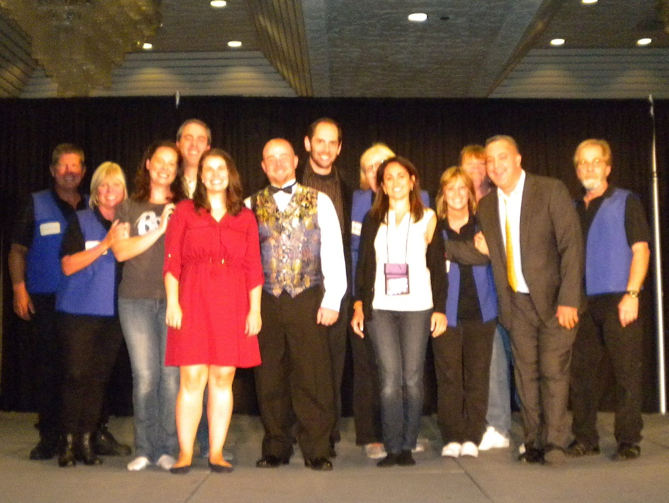

LOVE/SICK

THE VILLAGE PLAYERS

SOUTHWEST REGION

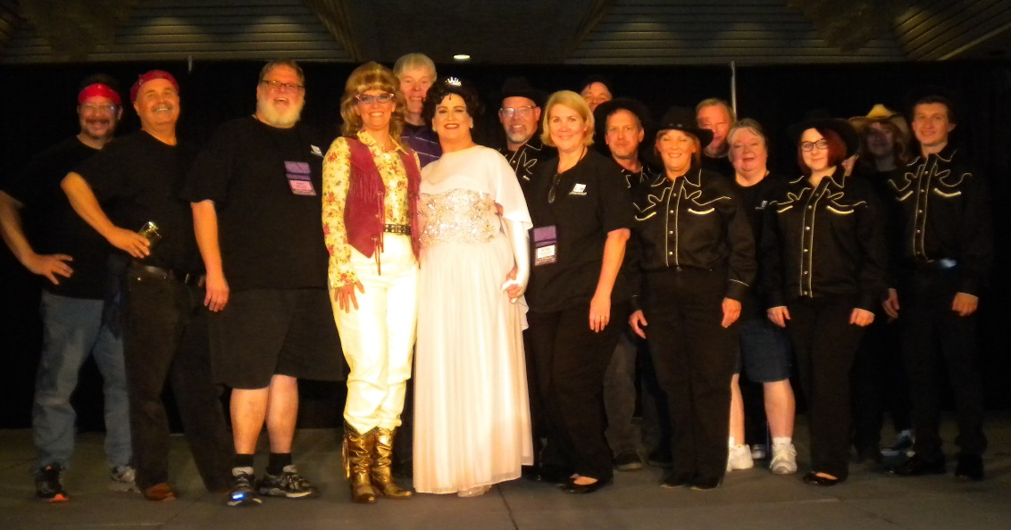

ALWAYS, PATSY CLINE

THE DRAMA WORKSHOP

SOUTHWEST REGION

**OHIO COMMUNITY THEATRE ASSOCIATION**

**PAST PRESIDENTS - 1953 – 2018**

Temp 5/1953 -

Dorman Richardson

9/1953 - Dorman Richardson

1954 - Donald Kleckner

1955 - Donald Kleckner

1956 - Emory B Michel

1957 - Emory B Michel

1958 - Roy Hall

1959 - Roy Bowen

1960 - William Allman

1961 - Richard Boyd

1962 - Jak Barrow

1963 - Reuben Silver

1964 - Reuben Silver

1965 - Harold Eisenstein

1966 - Harold Eisenstein

1967 - Jean Barger

1968 - Jean Barger

1969 - Jean Barger

1970 - Donald Rosenberg

1971 - Robert McKnight

1972 - Eleanor Heyman

1973 - Art Rouse

1974 - Syd Spate

1975 - Cecil Goldsmith

1976 - Cecil Goldsmith

1977 - Jack Paullus

1978 - Jack Paullus

1979 - Bruce Scranton

1980 - Suzanne Annis

1981 - Gail Anderson

1982 - Gail Anderson

1983 - Pam Scheer

1984 - Pam Scheer

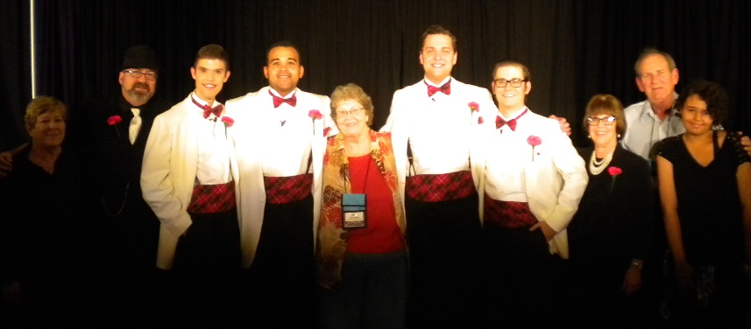

1985 - Allyn Barnes

1986 - Allyn Barnes

1987 - Michael Schacherbauer

1988 - Michael Schacherbauer

1989 - Bob Beasley

1990 - Bob Beasley

1991 - Michael Schacherbauer

1992 - Jerry Zimmerman

1993 - Jerry Zimmerman

1994 - Shari Hartsock

1995 - Lisa Billing

1996 - Lisa Billing

1997 - Michael Schacherbauer

1998 - Jerry Zimmerman

1999 - Ginny Morrison

2000 - Ginny Morrison

2001 - Jerry Zimmerman

2002 - Jerry Zimmerman

2003 - Christi Thomas

2004 - Christi Thomas

2005 - Susan Metz Foster

2006 - Jerry Zimmerman

2007 - Jerry Zimmerman

2008 - Ginny Morrison

2009 - Ginny Morrison

2010 - Ginny Morrison

2011 - Ginny Morrison

2012 - Joe Barton

2013 - Joe Barton

2014 – John Falkenbach

2015 – Dawna Kornick

2016 – Dawna Kornick

2017 – Jesse Bernal

FOREVER PLAID

COSHOCTON FOOTLIGHT PLAYERS

SOUTHEAST REGION

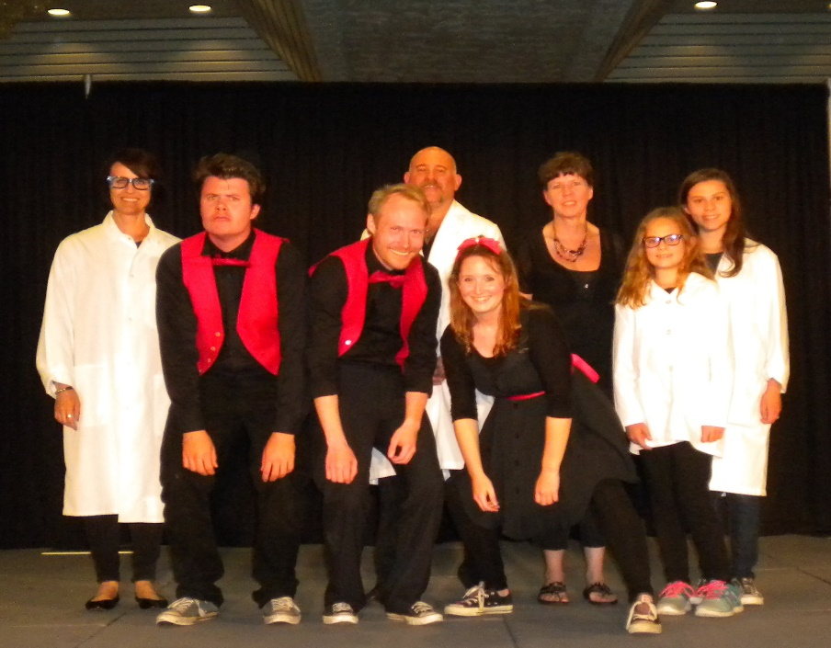

WORDS, WORDS, WORDS

AURORA COMMUNITY THEATRE

NORTHEAST REGION

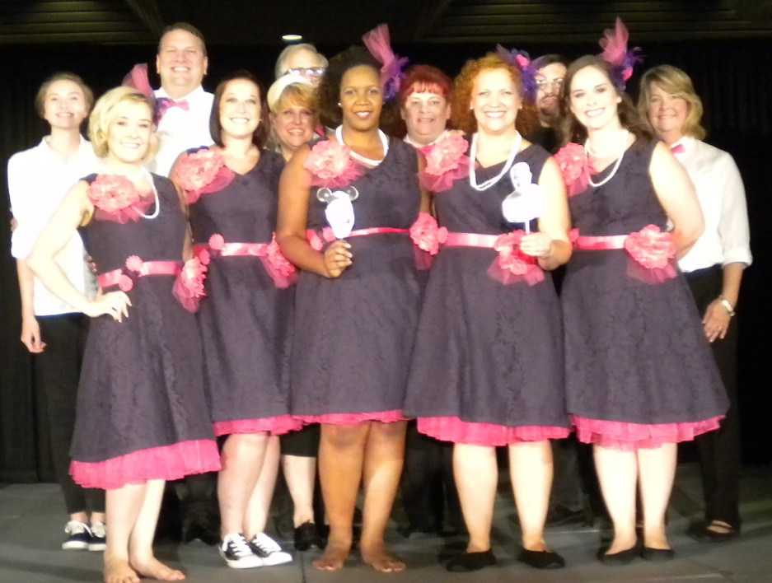

5 WOMEN WEARING THE SAME DRESS

CURTAIN PLAYERS

CENTRAL REGION

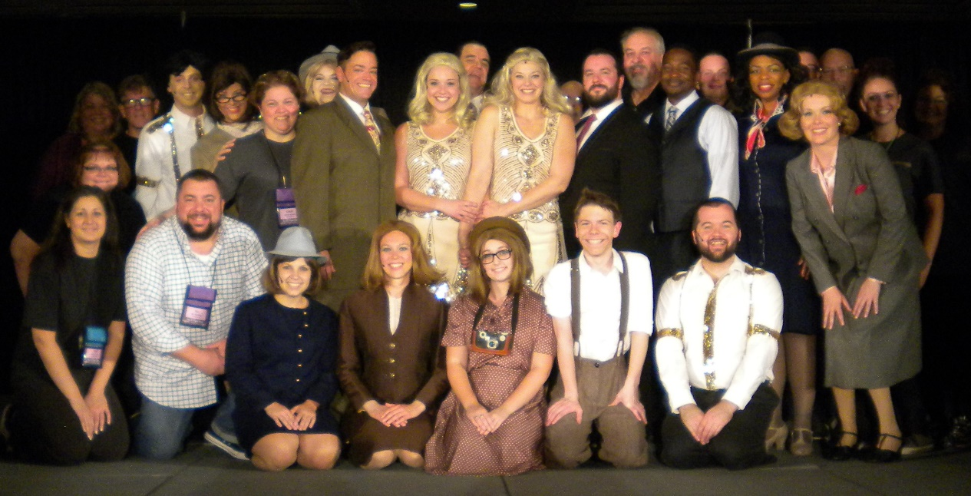

SIDE SHOW

FOOTLIGHTERS

SOUTHWEST REGION

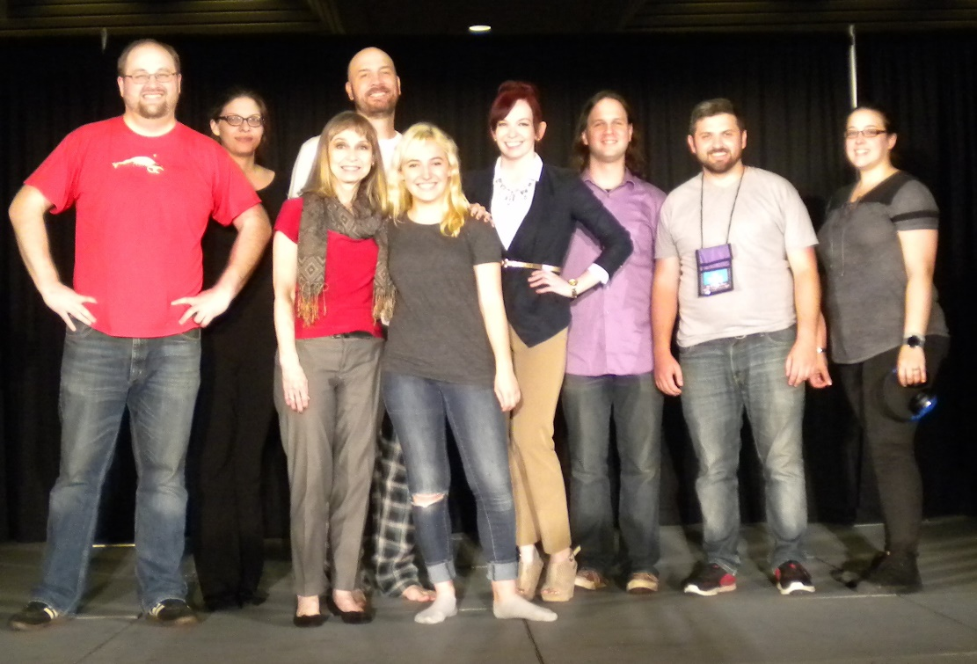

EMPTY NEST

LICKING COUNTY PLAYERS

CENTRAL REGION

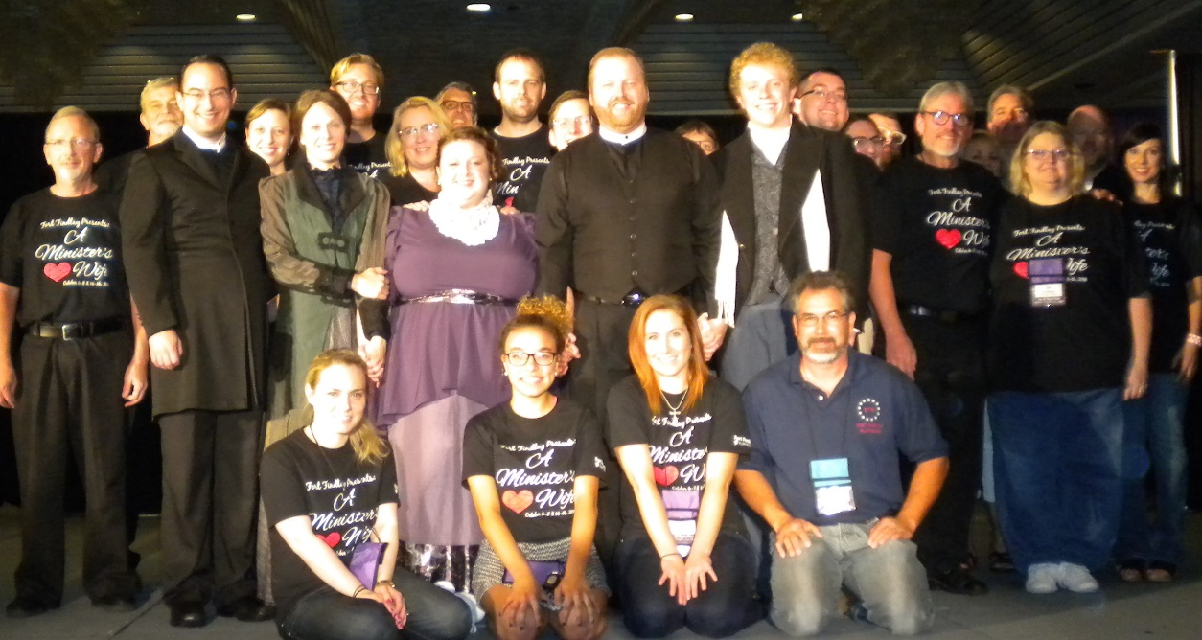

THE MINISTER WIFE

FORT FINDLAY PLAYHOUSE

NORTHWEST REGION

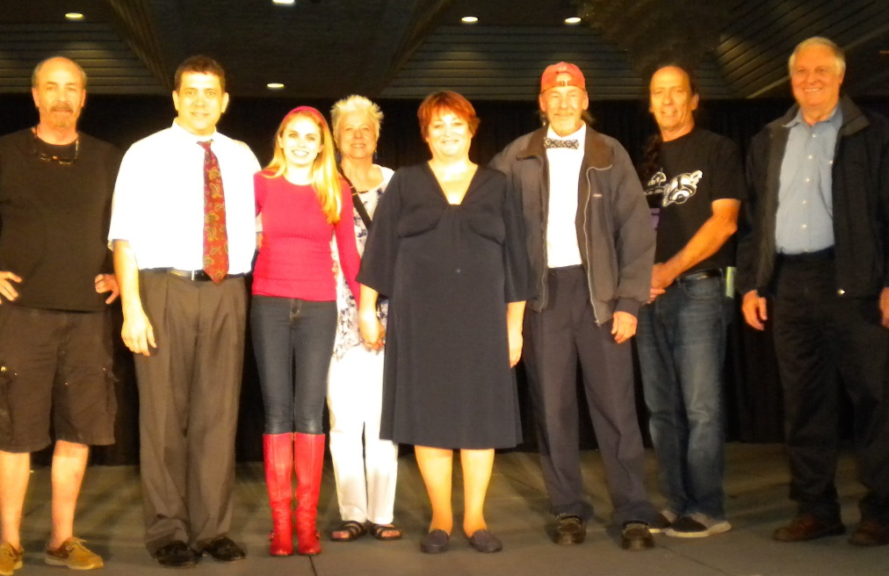

BAREFOOT IN THE PARK

TRUMBULL NEW THEATRE

NORTHEAST REGION

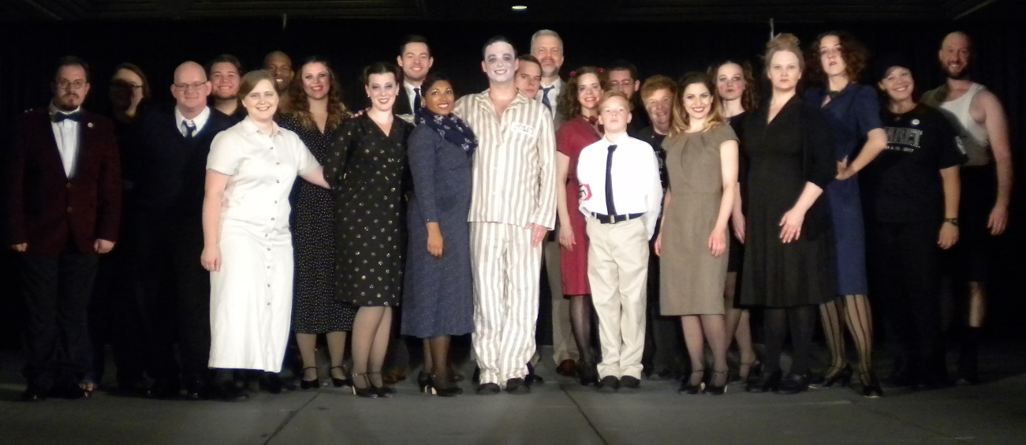

CABARET

CUTTING EDGE THEATRE COMPANY

NORTHWEST REGION

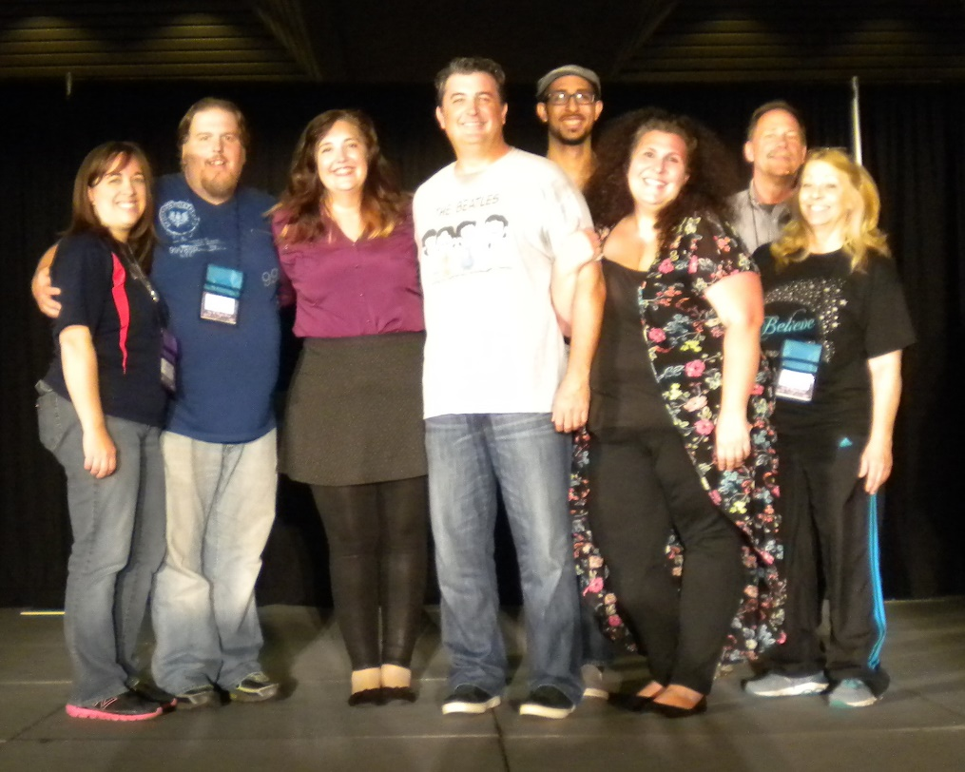

FIDDLER ON THE ROOF

WATERVILLE PLAYSHOP

NORTHWEST REGION

HERE ON THE FLIGHT PATH

THEATRE 8:15

NORTHEAST REGION

