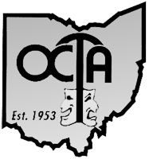 REGIONAL OCTAFEST FINAL REPORT - 2022

Please complete this form following your regional festival to help us plan for the future, tax reporting and possible grant submission.

Region: Date(s) of Festival:

1. How many minorities attended: Asians African/American

Appalachian Latino/Hispanics Native American Seniors over 62

2. How many theatres were represented? (not just excerpts)

Total number of individuals attending festival

Total paid individuals attending

Total complimentary individuals attending

Total Board Members attending Other Regional Reps

Others attending (corporate, government, etc.)

Early Bird Prices: Adult/Senior Number sold

Early Bird Prices: Student/Child Number sold

Ticket prices: Adult/Senior Number sold

Ticket prices: Student/Children Number sold

Number of Excerpts Number of workshops

3. Who served as Responders:

4. How many theatres substituted in their casts?

5. Your Regional Invitee(s) (Theatres and Show Titles)

6. Your Alternate excerpt: (Theatre and Show Title)

7. Total Festival Income $ Total Festival Expense $

8. List Additional Comments on back:

Return this form within 2 weeks of your Festival to:
Aara Wise, OCTA Administrative Asst., 464 Sherwood Downs Rd. S, Newark, OH 43055

